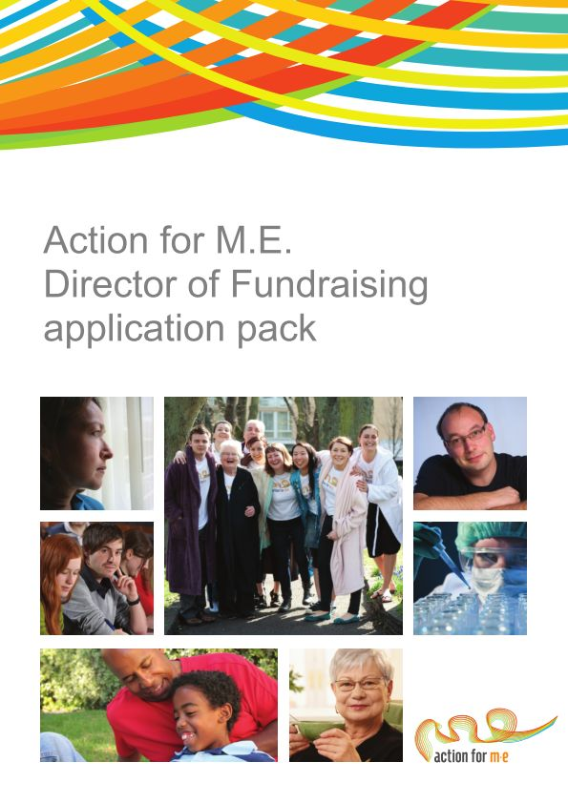



[Type a quote from the document or the summary of an interesting point. You can position the text box anywhere in the document. Use the Drawing Tools tab to change the formatting of the pull quote text box.]

**Action for M.E.**

**Chair, Board of Trustees Application Pack**

**Thank you for considering joining Action for M.E.**

This is an incredibly exciting time in the charity’s development as we look to recruit a new Chair to help lead our new bold and ambitious agenda strategy for change.

I joined Action for M.E. in September 2012 and am delighted to be working with a staff and volunteer team and Board of Trustees who are passionate, dedicated and determined.

We are in the process of developing our new five-year strategy and know that we need to have a stronger clarity of purpose and a sharper purpose on what we will and won’t do and what difference our action will have for people with M.E.

The impact for people affected by M.E., a hidden illness with significant lack of awareness and understanding of the condition and the devastating effects it can have, has grown. As a result transformational changes are needed now, more than ever.

We believe that Action for M.E. can, and will, make a major contribution to creating the change that is so desperately needed.



**Sonya Chowdhury**

**Chief Executive**

**Our values**

Shared values are held with high regard in our organisation and reflect how we seek to work with our supporters, partners and other key

stakeholders. They reflect the attitudes, beliefs and behaviour that we value in each other and underpin our whole approach and culture.

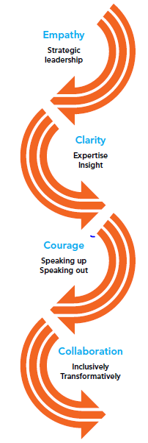

**About us**

Action for M.E. takes action to end the ignorance, injustice and neglect that people with M.E. face day-in, day-out.

M.E. is a chronic, neurological illness affecting an estimated 250,000 adults and children in the UK. It may be diagnosed as Chronic Fatigue Syndrome (CFS) or Post Viral Fatigue Syndrome (PVFS).

M.E. affects different people in different ways and symptoms can fluctuate and change over time. Common symptoms include persistent and severe exhaustion that doesn’t improve with rest, muscle and/or joint pain, sleep disturbance, having problems with memory and concentration.

Action for M.E. was founded by Sue Finlay in 1987 and since then has been working tirelessly to tackle the inequality experience by people with M.E.

**Our vision**

A world without M.E.

**Our mission**

Empowering people with M.E. to fulfil their potential and secure the care and support they need, while working towards a greater understanding of the illness and ultimately a cure.

**Our people**

**President**

Clare Francis MBE

**Vice President**

Martin Arber

**Patrons**

Lord David Puttnam CBE

Lord Melvyn Bragg

Julie Christie

Professor Anthony J. Pinching

**Chairman**

Alan Cook CBE

**Vice Chairman**

Vacant

**Trustees**

We are an organisation led by people affected by M.E. for people affected by M.E. We aim to have a minimum of 51% of our Trustees who have, or have had, M.E. themselves.

Our Trustees are unpaid and meet at least four times a year and many sit on one of our four sub-committees. Board meeting location alternates between London and Keynsham.

We have a staff team of 18 (13.5 FTE) and approximately 70 volunteers who support our work in a number of different ways.

Our head office is in Keynsham (between Bath and Bristol) and we also have a small number of staff and volunteers in Edinburgh.

**Our three strategic touchstones…**

**Our promise to people affected by M.E.**

**Inform and Influence**

We will increase awareness and understanding of the illness and its impact alongside working to influence policy-makers and others to increase investment in research and improve the services, care and support for people affected by M.E.

**Empower and Support**

We will empower and support people affected by M.E. to live life to their full potential, while providing them with a wide range of up-to-date information about M.E. and resources available to them.

**Research**

We will support high quality, evidenced-based medical and social policy research and invest in pilot research projects to help us learn more and to stimulate greater mainstream funding of M.E. research.

**“Ensuring impact from all   
our work”**

**Redefining our priorities…**

There is much to do. We have pulled together the voices, views and opinions from a number of our key stakeholders and will be reviewing and refining our focus for the next five to ten years.

Currently, our key priorities that will shape our current and future activities:

* awareness and understanding
* health
* welfare
* research
* employment

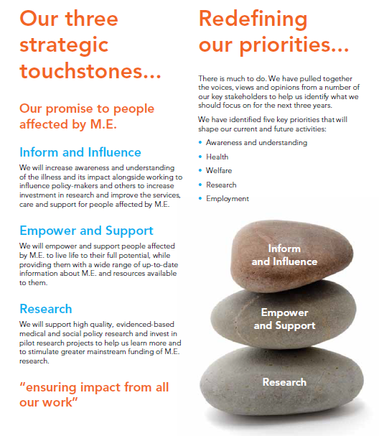

**Chair role description**

Action for M.E. is a registered charity and a company limited by guarantee. The successful applicant will therefore be required to become a Trustee, in accordance with the Charities Commission, and a Director, in accordance with Companies House.

**Main duties:**

1. To provide effective leadership to the Board of Trustees/Directors ensuring that it fulfils its responsibilities and accountabilities for good governance of the Charity.
2. To work in partnership with, and support, the Chief Executive helping them to achieve the mission of the organisation.
3. To optimise the relationship between the Board and staff/volunteers.
4. To create additional value for the Charity through soliciting additional resources in at least one of the following areas: policy/influence, awareness-raising, press/media and income generation.

**In more detail:**

**To provide effective leadership to the Board of Trustees/Directors**

* Ensure that the Board sets the vision, mission, top-level strategy and high-level policies for the Charity within the powers and restrictions in its charitable objects and governing instruments.
* Ensure that Trustees fulfil their duties and responsibilities for the proper governance and legal compliance in all aspects of the Charity’s activities.
* Ensure internal controls and systems are in place (both financial and non-financial) and are audited and reviewed on a regular basis.
* Ensure that the Board regularly reviews its structure, role and relationship to staff to create an effective flow of leadership and implements agreed changes as necessary to maintain effective performance and ensure it does not slip incrementally, or otherwise, into the management role.
* In close consultation with the Chief Executive, make recommendations on the composition of the board, and future Chairs and officers of the Board (with a view to succession).
* With the Chief Executive, develop appropriate agendas for meetings ensuring that all matters requiring Board review are discussed and Chair meetings of the Board ensuring that it functions effectively.

**To work in partnership with, and support, the Chief Executive helping them to achieve the mission of the organisation**

* Ensure that the Board and the Charity puts people with M.E. at the heart of everything they do, listening to the voices and views of key stakeholders, especially people with M.E., the Chief Executive, staff and volunteers.
* Provide leadership to the Chief Executive to ensure the Charity is run in accordance with the decisions of the Board of Trustees and the Charity’s governing documents and that there is clarity about the Charity’s purpose and objectives at all levels.
* Ensure that through the Chief Executive, a performance evaluation process is in place for everyone in the Charity and that the Chief Executive is clear about the key performance indicators by which they will be held accountable.
* When necessary, ensure that the Chair and the Trustees challenge the Chief Executive constructively, as critical friends, and only in the best interests of the Charity.
* Ensure the Chief Executive understands their crucial responsibility to provide relevant, honest, timely, high-quality information and advice to the Board of Trustees.
* With the Chief Executive, ensure there are appropriate mechanisms, both internal and external, to verify that the Board of Trustees receives a balanced and honest picture of how the Charity is operating and performing.

**To optimise the relationship between the Board and staff/volunteers**

* Through the Chief Executive, ensure effective communication between the Board and the staff/volunteer team, and in particular, senior managers and ensure that the Chief Executive provides an effective link.
* Ensure, through the Chief Executive, that the staff understand the role of the Board of Trustees and that the Chief Executive provides and effective link between the Board, staff and volunteers.
* Ensure that whenever practicable, Trustees visit various parts of the Charity, attend appropriate events organised by the Charity and have informal opportunities to meet the staff, volunteers and beneficiaries.
* Comply with current employment and equalities legislation and good practice.

**To create additional value for the Charity and solicit additional resources and support**

* Use your expertise and own networks to create and secure support for the charity in at least one of the following areas: policy/influence, awareness-raising, press/media and income generation.
* Support and encourage Board members to also secure appropriate support for the Charity to maximise its reach and benefit for people with M.E.
* Represent and promote the Charity in a range of differing public and private forums, the press and media, as appropriate and agreed with the Chief Executive.

**Chair person specification**

|  |  |
| --- | --- |
| **To provide effective leadership to the Board of Trustees/Directors** | |
| Established reputation and proven leadership experience in an organisational setting ideally including experience as a Chair and/or Committee work | Essential |
| Significant experience of operating at a senior level in a strategic capacity | Essential |
| Ability to support, challenge and manage a relationship with the Board ensuring continual development and effectiveness | Essential |
| Good, independent judgment, tact and diplomacy | Essential |
| An understanding and acceptance of the legal duties, responsibilities and liabilities of trusteeship/directorship | Essential |
| Meet the requirements of the Charity Commission ‘fit and proper person’ criteria: <https://www.gov.uk/government/uploads/system/uploads/attachment_data/file/392977/model-dec-ff-persons.pdf> | Essential |
| **To work in partnership with, and support, the Chief Executive helping them to achieve the mission of the organisation** | |
| Ability to hold and set strategic vision | Essential |
| Support the CEO to ensure effective delivery and implementation of the strategy providing constructive support and challenge for individual and organisational development | Essential |
| **To create additional value for the Charity and solicit additional resources and support** | |
| Willingness to be an ambassador for the Charity | Essential |
| Experience of press/media work and an ability to be a figurehead for the Charity when required | Essential |
| Proven expertise in at least one of the following areas: policy/influence, business development and generating income | Essential |
| A willingness to use skills, experience and own networks to create and secure value for the Charity to effectively deliver its strategic objectives and goals | Essential |
| **To optimise the relationship between the Board and staff/volunteers and other cross-cutting requirements** | |
| A commitment to the organisation, its purpose and cause and demonstrate an understanding of M.E. and its impact on people with the illness and others affected by it | Essential |
| Ability to build and maintain strong, transparent relationships with key stakeholders | Essential |
| Strong interpersonal, communication and negotiation skills and the ability to develop effective, sustainable partnerships | Essential |
| Resilience and ability to make things happen | Essential |
| Innovative thinker and ability to focus on the issues to be dealt with | Essential |
| Dynamism, enthusiasm and energy | Essential |
| A commitment to working within Action for M.E.’s values and principles of working, including Nolan’s ‘Seven Principles of Public Life’:     * Selflessness * Integrity * Objectivity * Accountability * Openness * Honesty * Leadership   A willingness to devote the necessary time and effort including a minimum of four Board meetings a year, an AGM, one-to-one sessions with CEO plus *ad hoc* support and engagement outside of meetings. | Essential |

**More information**

All Trustees and Officers receive a full induction and there are bi-annual development days for Trustees with the CEO and Senior Leadership Team. We also provide a Trustee Handbook and a copy of NCVO’s ‘Good Trustee Guide’.

To ensure that the Board functions effectively, the Chairperson will be required to attend all Board meetings in person.

There are four sub-committees of the Board of Trustees. Most Trustees participate in at least one sub-committee:

* Audit, Finance and Fundraising Committee
* Research Panel
* Policy Group
* Remunerations and Nominations Committee (REMCO).

The Chair of the Board will also be required to Chair REMCO; this committee meets only when there is a need to.

**How to apply**

If you are interested in becoming a trustee, please submit your CV and completed Equal Opportunities Monitoring and Information Form below with a covering letter outlining why you would like to become a trustee and how you meet **all aspects of the person specification outlined above**. You must also provide two referees that we can approach should you be successful following interview.

Please also indicate any reasonable adjustments that you may require to enable us to provide a good recruitment process with you.

**Timetable**

|  |  |
| --- | --- |
| Closing date for applications | 31 May 2016 |
| Interview and opportunity to meet some staff and Trustees(to be held at the office in Keynsham) | 21 or 23 June 2016 |
| Successful candidate’s opportunity to observe Board meeting and meet other Trustees | 8 September 2016 (Keynsham) |
| Supporting members voting (for new Trustees) | August – October 2016 |
| AGM and confirmation of appointment | November 2016 |

For more information, or to submit an application, please contact Anna Whitson at Action for M.E., 42 Temple Street, Keynsham BS31 1EH. Tel: 0117 927 9637. Email: anna@actionforme.org.uk

**Equal opportunities Monitoring and Information Form**

Action for M.E. is committed to its equal opportunities policy. This means that we shall treat all applicants and employees fairly and equally, irrespective of race, colour, age, ethnic or national origins, sex, religious belief, gender reassignment, trade union activity, marital status, sexual orientation or disability.

The information you provide here is confidential, and will be used for monitoring purposes only. It will not be seen by the short-listing or interview panels. Please return this form with your application.

**Please tick the boxes that apply to you:**

|  |  |
| --- | --- |
| **Age group**:   * 21 – 30 * 31 – 40 * 41 – 50 * 51 – 65 * 65+ * Do not wish to answer | **Gender:**   * Male * Female * Do not wish to answer |
| **Ethnic Origin:**  **White**   * British * Irish * Other European * Other…………………………… | **Asian**   * Asian British * Bangladeshi * Indian * Pakistani |
| **Black**   * African * Black British * Caribbean * Other…………………………….. | **Chinese**   * Chinese   **Other**   * Other…………………………… |
| **Mixed race**   * White and Asian * White and Black African * White and Black Caribbean | * White and Chinese * Other…………………………….. |

**Equality Act 2010**

The Equality Act protects people from unlawful legislation. If you tell us that you have disability, we will make reasonable adjustments to your working environment and your work practices, if it is reasonable for us to do so.

You’re disabled under the Equality Act 2010 if you have a physical or mental impairment that has a ‘substantial’ and ‘long-term’ negative effect on your ability to do normal daily activities.

|  |  |
| --- | --- |
| Do you consider yourself to have disability? | * Yes* * No |

*If yes, please indicate which category best describes your disability:

* Hearing impairment
* Visual impairment
* Speech impairment
* Mobility impairment
* Physical co-ordination (eg. manual dexterity/muscle control)
* Reduced physical capacity (eg. severe pain, lack of strength, breath or stamina)
* Learning difficulties
* Mental illness
* Other……………………………………………………………………………...……………………………………………………………………………………………….

**Advertising and publicity**

Please tell us how you heard of this vacancy:

* Website (please specify)………………………………………………………
* Newspaper (please specify)……………………………………………………….
* Other (please specify)………………………………………………………

**For more information**

Visit our Online M.E. Centre at www.actionforme.org.uk where you can find out more about M.E. and the work we do including our *Statement of Strategic Intent 2013-16* or contact Action for M.E. on 0117 927 9551