


Action for M.E.
Information & Support Officer
application pack

Thank you for considering joining Action for M.E.

I joined Action for M.E. in September 2012 and am delighted to be working with a staff and volunteer team and Board of Trustees who are passionate, dedicated and determined.

Our 2016 – 2021 strategy, launched at our 2016 AGM and conference, sets out how we meet need now to improve the lives of people with M.E. while taking action to secure change for the future.

A small organisation that regularly punches above its weight, we are leading, with others, a growing community of supporters working to create real change on the scale so urgently needed at a local, national and international level.

I believe that Action for M.E. can, and will, make a major contribution to creating the change that is so desperately needed.



Sonya Chowdhury
Chief Executive

Our values

Shared values are held with high regard in our organisation and reflect how we seek to work with our supporters, partners and other key
stakeholders. They reflect the attitudes, beliefs and behaviour that we value in each other and underpin our whole approach and culture.

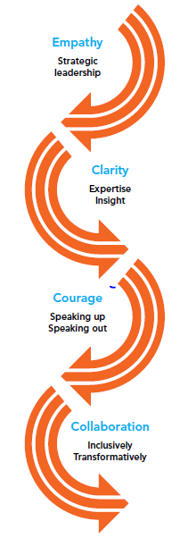

About us

Action for M.E. takes action to end the ignorance, injustice and neglect that people with M.E. face day-in, day-out.

The charity was founded by Sue Finlay in 1987 and since then has been working tirelessly to tackle the inequality experienced by people with M.E.

M.E. (Myalgic Encephalomyelitis) is a chronic, neurological illness affecting an estimated 250,000 adults and children in the UK. It may be diagnosed as Chronic Fatigue Syndrome (CFS, or M.E./CFS).

People with M.E. experience severe, persistent fatigue associated with post-exertional malaise, the body’s inability to recover after expending even small amounts of energy, leading to a flare-up in symptoms.

Even in its so-called mildest form, M.E. can have a significant impact on an individual’s life, and not just on their health. A lack of understanding and awareness about M.E. means patients can experience disbelief, and even discrimination, from friends, family, health and social care professionals and employers.

Our vision

A world without M.E.

Our mission

Empowering people with M.E. to fulfil their potential and secure the care and support they need, while working towards a greater understanding of the illness and ultimately a cure.

Our people

President
Clare Francis MBE

Vice President
Martin Arber

Patrons
Lord David Puttnam CBE
Lord Melvyn Bragg
Julie Christie
Professor Anthony J. Pinching

Chair of Board of Trustees
Jonah Grunsell

Vice Chair
Vacant

Board of Trustees
We are an organisation led by people affected by M.E. for people affected by M.E. We aim to have a minimum of 51% of our Trustees who have, or have had, M.E. themselves.

Our Trustees are unpaid and meet at least four times a year and many sit on one of our four sub-committees. Board meeting location alternates between London and Keynsham.

We have a staff team of 16 (12.7 FTE) and approximately 70 volunteers who support our work in a number of different ways.

Our head office is in Keynsham (between Bath and Bristol) and we also have a small number of staff and volunteers in Scotland.

Over the next five years, our purpose is to end the ignorance, injustice and neglect experienced by people with M.E.

People with M.E. are at the heart of everything we do. We asked and we listened, and have identified a number of challenges that continue to exist for people affected by M.E.
Everything we do over the next five years will be in service of achieving three goals, which we call our strategic touchstones.

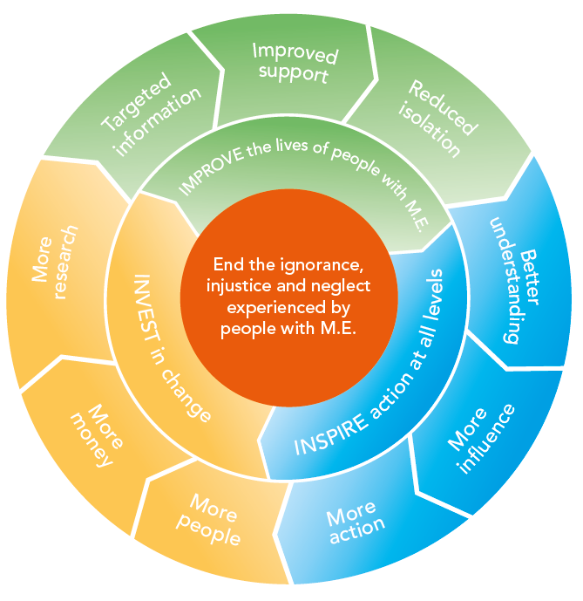

By collaborating with those who share our vision and purpose, we can make the most of the resources available to us.
Around 50% of our activities will directly focus on targeting information, improving support and reducing isolation to IMPROVE the lives of people with M.E. To be as effective as possible, 30% of our activities will focus on facilitating more action, more influence and better understanding of M.E. to INSPIRE action at all levels; and 20% of our activities will be focused on bringing more research, more money and more people into the field to INVEST in change.

Job summary

Job title | Information & Support Officer
Responsible to | Director of Services and Development
Responsible for | Volunteers
Salary | £16,000 – £18,500 pro rata dependent on skills and experience
Hours of work | 26 hours, ideally spread Monday to Friday during office hours
Annual leave | 26 days pro rata + grace days to be taken at Christmas as directed
Location | Keynsham

Job purpose

This post delivers the information and support service provided by Action for M.E.
The post holder will often be the first point of contact for a person seeking help and support in managing M.E. and the successful applicant will work alongside other staff to provide targeted information and support to people affected by M.E.

They will also be responsible for carrying out office administrative tasks, reporting to the Director of Services and Development.

Key duties

- Information and support
- Responding to telephone, email and postal enquiries to the charity from people affected by M.E. on a wide range of issues including sensitive and confidential matters.
- Providing information and signposting to Action for M.E. services and resources and/or other organisations as necessary.
- Maintaining an anonymised logging system of enquiries and collecting supporting management information to inform fundraising activities and service development; and supporting/maintaining CRM database (training provided).
- Coordinating the telephone support rota to provide cover and back-up support.

- General administration and other duties
- Overseeing and managing the post
- Ordering and maintaining office stationery.
- Supporting administrative/support volunteers.
- Undertaking elements of office administration, as required by the Director of Services and Development.
- Positively promoting the work and activities of Action for M.E. at all times.
- Keeping up-to-date with best practice and comply with relevant legislation and regulatory requirements, working within the organisation’s policies and procedures and ensure that good practice is observed.
- Undertaking any other reasonable activity in line with the responsibilities of the post as requested by the Director of Services and Development.

Person specification

Qualifications, skills, experience and knowledge | Essential | Method of Assessment
- Possess 5 GCSE’s (grade C or above) to include English and Maths or proven transferable and relevant experience | Y | Application/Interview
- Experience of working in a customer-care or helpline role | Y | Application/Interview
- Experience in an office environment carrying out administrative tasks | Y | Application/Interview
- An excellent telephone manner and the ability to communicate confidently and empathetically with a wide range of people | Y | Application/Interview
- A high standard of literacy and numeracy; able to demonstrate accuracy and attention to detail. | Y | Application/Interview
- Computer literate in MS Office | Y | Application/Interview
- Able to work methodically; managing and prioritising a varied workload | Y | Application/Interview
- Understanding of the key issues faced by people living with a long-term, debilitating illness | Y | Application/Interview
- Ability to use own initiative and work well in a team | Y | Application/Interview
- Understanding of M.E. and its impact | Desirable | Application/Interview
- Previous experience in a charity | Desirable | Application/Interview
- Experience of basic financial administration (receiving and logging cheques, accepting donations) | Desirable | Application/Interview
- Experience of using social media and Skype (or similar) | Desirable | Application/Interview

Terms and conditions

Outlined below are some of the main terms and conditions of employment relevant to all employees of Action for M.E.

1. Probation
All posts are subject to three months’ probation. During this probationary period, either party may give the other one week’s notice in writing to terminate the employment. After successful completion of the probationary period, the notice stated on your contract of employment will apply.

2. Annual leave
The holiday year runs from 1 April to 31 March. In each holiday year in addition to bank and statutory holidays the holiday entitlement for a full time employee is 26 days. Holiday will be calculated on a pro rata basis for part time posts.

3. Pension scheme
Action for M.E. operates a group pension scheme. All employees may join the scheme on the completion of the probationary period. Action for M.E. will match employees’ pension contributions of up to 3% of salary. Action for M.E. will not pay into a personal pension scheme.

4. Salary payment
Salaries are paid in arrears on the last working day of each month, by direct credit transfer into a bank or building society.

5. Flexibility
This post may require working outside of normal office hours and travel to attend meetings and events within the UK, including occasional overnight stays.

Application timetable

Deadline for applications | 9AM 13th February 2017
Short list meeting | 13th February 2017
Successful applicants to be notified by | 14th February 2017
Interviews | 20th February 2017

For more information, or to submit an application, please contact Anna Whitson at Action for M.E., 42 Temple Street, Keynsham BS31 1EH. Tel: 0117 937 6637.
Email: anna@actionforme.org.uk

 | Application form  for the post of  Information & Support Officer

Please PRINT and use black ink if not completing electronically. This form must be completed in full. Any additional information submitted (eg. CV) will not be considered in the shortlisting process.

Personal details

Surname | First name(s) | Title
Address

Email address

Office hours telephone number | Other hours telephone number | Mobile number
Do you need a work permit for permanent employment in the UK? YES / NO |  | If so, do you have one?  YES / NO

Please provide education history and qualifications

Name of school, college or university | Date  from – to – | Qualifications gained
Please provide full work history (please ensure you account for any gaps in employment)

Job title and responsibilities | Organisation/Employer | Date  from – to – | Reason for leaving

Please provide current salary details (or last post if not in current employment) £_______

Please describe, in no more than two pages, why you want this role and how you fit the person specification set out in this application pack

Referees

Please note that a verbal reference will be picked up for the successful candidate prior to making a verbal offer to them
Name  Address  Telephone  E-mail address:  Relationship to you | Name  Address  Telephone  E-mail address:  Relationship to you

Declaration

I declare that all the information I have given on this application form is true to the best of my knowledge and belief. I understand that my application may be rejected and/or that I may be dismissed if I have given information which is found to be false.

Signed…………………………………………………………..

Date……………………………………………………………...

Please return this form to anna@actionforme.org.uk

Data Protection Act 1998
Information provided on this application form will be treated as confidential and held in secure conditions. Access will be restricted to those involved in the recruitment and selection process. Data you provide may be copied for use in the recruitment process and once this is completed, the information will be stored for a maximum of 12 months and then destroyed. If you are the successful candidate, relevant information will be taken from your application and transferred to your personal file. We are unable to process your application unless we can use your personal data. By signing and submitting this form, you are giving your consent to the processing of your data in the ways described.

Equal opportunities monitoring and information form

Action for M.E. is committed to its equal opportunities policy. This means that we shall treat all applicants and employees fairly and equally, irrespective of race, colour, age, ethnic or national origins, sex, religious belief, gender reassignment, trade union activity, marital status, sexual orientation or disability. The information you provide here is confidential, and will be used for monitoring purposes only. It will not be seen by the short-listing or interview panels. Please return this form with your application.

Please tick the boxes that apply to you:

Age group:  - 21 – 30  - 31 – 40  - 41 – 50  - 51 – 65  - 65+  - Do not wish to answer | Gender:  - Male  - Female  - Do not wish to answer
Ethnic Origin:  White  - British  - Irish  - Other European  - Other…………………………… | Asian  - Asian British  - Bangladeshi  - Indian  - Pakistani
Black  - African  - Black British  - Caribbean  - Other…………………………….. | Chinese  - Chinese  Other  - Other……………………………
Mixed race  - White and Asian  - White and Black African  - White and Black Caribbean | - White and Chinese  - Other……………………………..

Equality Act 2010

The Equality Act protects people from unlawful legislation. If you tell us that you have disability, we will make reasonable adjustments to your working environment and your work practices, if it is reasonable for us to do so.

You’re disabled under the Equality Act 2010 if you have a physical or mental impairment that has a ‘substantial’ and ‘long-term’ negative effect on your ability to do normal daily activities.

Do you consider yourself to have disability? | - Yes*  - No

*If yes, please indicate which category best describes your disability:
- Hearing impairment
- Visual impairment
- Speech impairment
- Mobility impairment
- Physical co-ordination (eg. manual dexterity/muscle control)
- Reduced physical capacity (eg. severe pain, lack of strength, breath or stamina)
- Learning difficulties
- Mental illness
- Other……………………………………………………………………………...……………………………………………………………………………………………….

Advertising and publicity
Please tell us how you heard of this vacancy:

- Website (please specify)………………………………………………………
- Newspaper (please specify)……………………………………………………….
- Other (please specify)………………………………………………………

For more information

Visit our Online M.E. Centre at www.actionforme.org.uk where you can find out more about M.E. and the work we do or contact Action for M.E. on 0117 927 9551

