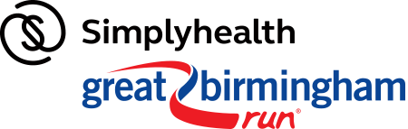
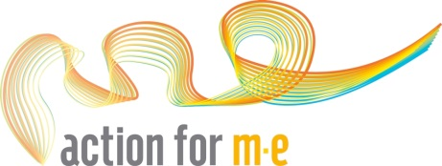

Great Birmingham Run
The Simplyhealth Great Birmingham Run is now established as the second biggest half marathon in the UK, as the city comes alive with thousands of runners pounding the streets as they tick off 13.1 miles, encouraged by on course bands, entertainment and cheering crowds.

Event details:

Name: Great Birmingham Run
Date: 15 October 2017
Distance: 13.1 miles
Registration fee: £20
Minimum Sponsorship: £200
Contact: fundraising@actionforme.org.uk

As a member of the Action for M.E. Great Birmingham Run team you will receive:
- A direct number to our friendly fundraising team
- A full fundraising pack including poster, leaflets and ideas.
- Access to our fundraising materials which include balloons, wristbands and collection tins
- A free running vest
- Our full support every step of the way.

Please note:
- Entrants need to be 17 years or over on race day
- By taking an Action for M.E. bond place you are pledging to raise £200 minimum sponsorship

How do I register for a place?
To enter please fill in the details below and return by
Email to: fundraising@actionforme.org.uk
Post to: Action for M.E., 42 Temple Street, Keynsham, BS31 1EH

To pay your £20 registration fee you can post a cheque with your registration form or to pay by debit or credit card, please call us on 0117 9376626 and we can take payment over the phone. Please note, your place is not confirmed until the registration fee has been paid.

Personal details:
Please write in capitals
First name: Surname:
Date of Birth:
Address:
Mobile number:
Email address:
Expected finish time:
Emergency contact name:
Emergency contact number:
Please specify your running vest size (unisex sizes): Small / Medium / Large / X-large
Please explain why you would like to take part for Action for M.E.:

Sharing your story with your local media helps promote your fundraising efforts, and raise awareness of M.E. Please would you be willing to let us send a press release featuring your story (including your name, age and general location, but not your full address, email or contact number) to journalists? Yes / No

Where did you hear about Action for M.E. Great Birmingham Run places?

Your preferences
I would like to receive a monthly update e-newsletter on Action for M.E.’s work and activities.
I do not wish to receive any appeals for money.

Pledge
I would like to register for a place in the Great Birmingham Run for Action for M.E. I agree to pay the £20 registration fee and pledge to raise a minimum sponsorship of £200
Signed: Date:

If you have any questions contact the fundraising team on 0117 937 6626 or by email at fundraising@actionforme.org.uk

Thank you!

