


Action for M.E.
Senior Fundraising Officer
application pack

Thank you for considering joining Action for M.E.

I joined Action for M.E. in September 2012 and am delighted to be working with a staff and volunteer team and Board of Trustees who are passionate, dedicated and determined.

Our 2016 – 2021 strategy, launched at our 2016 AGM and conference, sets out how we meet need now to improve the lives of people with M.E. while taking action to secure change for the future.

A small organisation that regularly punches above its weight, we are leading, with others, a growing community of supporters working to create real change on the scale so urgently needed at a local, national and international level.

In April 2017, we launched our Children’s Services after joining forces with the national children’s charity, AYME, which will cease operating.. This provides an exciting opportunity to raise more money to reach more people and raise much needed awareness and understanding.

I believe that Action for M.E. can, and will, make a major contribution to creating the change that is so desperately needed.



Sonya Chowdhury
Chief Executive

Our values

Shared values are held with high regard in our organisation and reflect how we seek to work with our supporters, partners and other key
stakeholders. They reflect the attitudes, beliefs and behaviour that we value in each other and underpin our whole approach and culture.

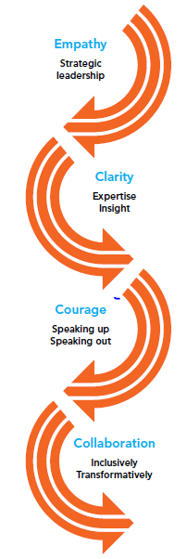

About us

Action for M.E. takes action to end the ignorance, injustice and neglect that people with M.E. face day-in, day-out.

The charity was founded by Sue Finlay in 1987 and since then has been working tirelessly to tackle the inequality experienced by people with M.E.

M.E. (Myalgic Encephalomyelitis) is a chronic, neurological illness affecting an estimated 250,000 adults and children in the UK. It may be diagnosed as Chronic Fatigue Syndrome (CFS, or M.E./CFS).

People with M.E. experience severe, persistent fatigue associated with post-exertional malaise, the body’s inability to recover after expending even small amounts of energy, leading to a flare-up in symptoms.

Even in its so-called mildest form, M.E. can have a significant impact on an individual’s life, and not just on their health. A lack of understanding and awareness about M.E. means patients can experience disbelief, and even discrimination, from friends, family, health and social care professionals and employers.

Our vision

A world without M.E.

Our mission

Empowering people with M.E. to fulfil their potential and secure the care and support they need, while working towards a greater understanding of the illness and ultimately a cure.

Our people

President
Clare Francis MBE

Vice President
Martin Arber

Patrons
Lord David Puttnam CBE
Lord Melvyn Bragg
Julie Christie
Professor Anthony J. Pinching

Chair of Board of Trustees
Jonah Grunsell

Vice Chair
Vacant

Board of Trustees
We are an organisation led by people affected by M.E. for people affected by M.E. We aim to have a minimum of 51% of our Trustees who have, or have had, M.E. themselves.

Our Trustees are unpaid and meet at least four times a year and many sit on one of our four sub-committees. Board meeting location alternates between London and Keynsham.

We have a staff team of 16 (12.7 FTE) and approximately 70 volunteers who support our work in a number of different ways.

Our head office is in Keynsham (between Bath and Bristol) and we also have a small number of staff and volunteers in Scotland.

Over the next five years, our purpose is to end the ignorance, injustice and neglect experienced by people with M.E.

People with M.E. are at the heart of everything we do. We asked and we listened, and have identified a number of challenges that continue to exist for people affected by M.E.
Everything we do over the next five years will be in service of achieving three goals, which we call our strategic touchstones.

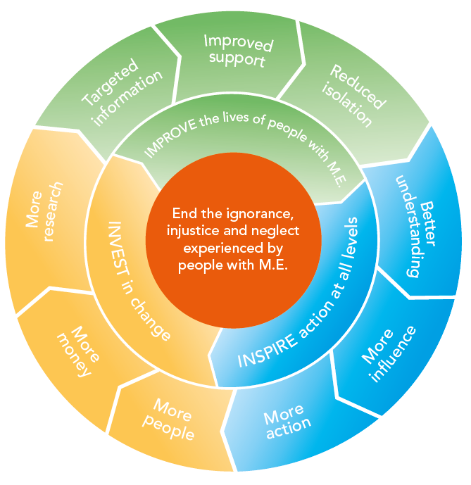

By collaborating with those who share our vision and purpose, we can make the most of the resources available to us.
Around 50% of our activities will directly focus on targeting information, improving support and reducing isolation to IMPROVE the lives of people with M.E. To be as effective as possible, 30% of our activities will focus on facilitating more action, more influence and better understanding of M.E. to INSPIRE action at all levels; and 20% of our activities will be focused on bringing more research, more money and more people into the field to INVEST in change.

Job summary

Job title | Senior Fundraiser
Responsible to | Chief Executive (for the immediate future)
Responsible for | Line management of Fundraising Officers and Volunteers
Salary | £25,000 – £29,500 pro rata dependent on skills and experience
Hours of work | Full time - 35 hours per week
Annual leave | 30 days pro rata
Location | Keynsham office

Job purpose

The purpose of this post is to maximise Action for M.E.’s income from a range of fundraising initiatives and events. The postholder will oversee income generation activity for all income streams except corporate partnerships and major donor fundraising. Alongside supporting junior fundraising colleagues, which accounts for about 10% of your time, you will bring your creativity to help the organisation raise more money from all its activity.

For the remaining time, you will be responsible for writing larger trust applications, supporting community fundraising, increasing membership and identifying ways to better steward and excite our donors through events and launching a mid-level donors’ club. We are keen to eventually expand our fundraising team which will lead to a restructuring and creation of a Fundraising Manager post. This post provides an opportunity for an ambitious individual who can help create this potential.

This post will play a crucial part in helping the charity to end the ignorance, injustice and neglect experienced by people with M.E. through generating income to fund its work.

Key duties

- Fundraising
- Supported by the line manager, implement the income generation strategy to maximise income across core funding streams.
- Oversee the trusts and foundations application pipeline, working with the trust fundraiser to ensure maximum success.
- Write bids for trusts and foundations ensuring appropriate applications are submitted and manage subsequent reporting and relationships with funding partners.
- Identify and manage appropriate activities to expand the charity’s individual donor-base, exploring and implementing methods to achieve this.
- Work with the Communications Team to ensure that we have compelling fundraising materials and exploit all marketing and social media opportunities to support fundraising activities.
- Work with the Chief Executive and Philanthropy Manager to ensure that all income generation activities are integrated across the organisation.
- Represent the Charity at events as part of our income generation work.
- Ensure efficient and effective systems underpin all our fundraising efforts.

- Line management
- Support and lead the fundraising officers in their respective areas of responsibility to achieve ambitious targets and maximise income generation throughout their work.
- Ensure that effective systems are in place for managing our database of supporting members and donors.
- Prepare regular management information reports in respect of all aspects of the charity’s fundraising activity (except corporate partnerships and major donor fundraising).
- Keep up-to-date with funding news and developments and with necessary procedures and best practice, ensuring key information is disseminated to colleagues accordingly.
- Contribute to the recruitment and support of volunteers within the fundraising team.

- Working with others
- Work closely with all teams (especially those that are focused on providing support services) to identify fundraising opportunities, share plans and create value.
- Develop and maintain relationships with supporters, a wide range of staff and volunteers from trustee level down.
- Support colleagues and contribute to the overall income generation strategy and planning process.

- Other duties
- To undertake any other duty within your ability and within reason, as may be required from time to time, at the direction of your line manager.
- Act as an advocate for the Charity and its work and contribute to raising the profile of M.E.
Person specification

Qualifications, skills, experience and knowledge | Essential | Method of Assessment
- Possess five GCSE’s (grade C or above) to include English and Maths | Y | Application/Interview
- Minimum four years’ professional experience in a fundraising role with demonstrable success of generating income | Y | Application/Interview
- Experience of using databases and spreadsheets | Y | Application/Interview
- Strong MS Office skills including ability to use Word, Excel, databases and web related | Y | Application/Interview
- Able to build relationships with a wide range of contacts at all levels whether junior staff, senior colleagues, donors or members of the public | Y | Application/Interview
- Knowledge of fundraising best practice and understand of relevant legal and regulatory requirements applicable to fundraising | Y | Application/Interview
- Excellent written and verbal communication and interpersonal skills including a good telephone manner | Y | Application/Interview
- Able to work methodically, managing and prioritising a varied workload with good attention to detail | Y | Application/Interview
- An understanding of M.E., the impact on people affected by it or a commitment and ability to understand the illness commensurate with the role | Y | Application/Interview
- Ability to use own initiative, work independently and to work well in a team | Y | Application/Interview
- Ability to give presentations to groups of varying size with people from varying backgrounds | Y | Application/Interview
- Previous experience in a charity | Y | Application/Interview
- Professional fundraising qualification | D | Application/Interview
Terms and conditions

Outlined below are some of the main terms and conditions of employment relevant to all employees of Action for M.E.

1. Probation
All posts are subject to three months’ probation. During this probationary period, either party may give the other one week’s notice in writing to terminate the employment. After successful completion of the probationary period, the notice stated on your contract of employment will apply.

2. Annual leave
The holiday year runs from 1 April to 31 March. In each holiday year in addition to bank and statutory holidays the holiday entitlement for a full time employee is 30 days (includes 3-4 days to be taken at Christmas as directed when office shut). Holiday will be calculated on a pro rata basis for part time posts.

3. Pension scheme
Action for M.E. operates a group pension scheme on an auto-enrolment basis. All employees will join the scheme on the completion of the probationary period unless they choose to opt-out. Action for M.E. will pay a matched pension contribution which is currently 3% of salary. Action for M.E. will not pay into a personal pension scheme.

4. Salary payment
Salaries are paid in arrears on the last working day of each month, by direct credit transfer into a bank or building society.

5. Flexibility
This post may require working outside of normal office hours and travel to attend meetings and events within the UK, including occasional overnight stays.

Application timetable

Deadline for applications | 5pm Thursday 4 May 2017
Short list meeting | Friday 5 May 2017
Applicants to be notified by | Monday 8 May 2017
Interviews | Thursday 18 May 2017

For more information, or to submit an application, please contact Anna Whitson at Action for M.E., 42 Temple Street, Keynsham BS31 1EH. Tel: 0117 937 6637.
Email: anna@actionforme.org.uk

 | Application form  for the post of  Senior Fundraiser

Please PRINT and use black ink if not completing electronically. This form must be completed in full. Any additional information submitted (eg. CV) will not be considered in the shortlisting process.

Personal details

Surname | First name(s) | Title
Address

Email address

Office hours telephone number | Other hours telephone number | Mobile number
Do you need a work permit for permanent employment in the UK? YES / NO |  | If so, do you have one?  YES / NO

Please provide education history and qualifications

Name of school, college or university | Date  from – to – | Qualifications gained
Please provide full work history (please ensure you account for any gaps in employment)

Job title and responsibilities | Organisation/Employer | Date  from – to – | Reason for leaving

Please provide current salary details (or last post if not in current employment) £_______

Please describe, in no more than two pages, why you want this role and how you fit the person specification set out in this application pack

Referees

Please note that a verbal reference will be picked up for the successful candidate prior to making a verbal offer to them
Name  Address  Telephone  E-mail address:  Relationship to you | Name  Address  Telephone  E-mail address:  Relationship to you

Declaration

I declare that all the information I have given on this application form is true to the best of my knowledge and belief. I understand that my application may be rejected and/or that I may be dismissed if I have given information which is found to be false.

Signed…………………………………………………………..

Date……………………………………………………………...

Please return this form to anna@actionforme.org.uk

Data Protection Act 1998
Information provided on this application form will be treated as confidential and held in secure conditions. Access will be restricted to those involved in the recruitment and selection process. Data you provide may be copied for use in the recruitment process and once this is completed, the information will be stored for a maximum of 12 months and then destroyed. If you are the successful candidate, relevant information will be taken from your application and transferred to your personal file. We are unable to process your application unless we can use your personal data. By signing and submitting this form, you are giving your consent to the processing of your data in the ways described.
Equal opportunities monitoring and information form

Action for M.E. is committed to its equal opportunities policy. This means that we shall treat all applicants and employees fairly and equally, irrespective of race, colour, age, ethnic or national origins, sex, religious belief, gender reassignment, trade union activity, marital status, sexual orientation or disability. The information you provide here is confidential, and will be used for monitoring purposes only. It will not be seen by the short-listing or interview panels. Please return this form with your application.

Please tick the boxes that apply to you:

Age group:  - 21 – 30  - 31 – 40  - 41 – 50  - 51 – 65  - 65+  - Do not wish to answer | Gender:  - Male  - Female  - Do not wish to answer
Ethnic Origin:  White  - British  - Irish  - Other European  - Other…………………………… | Asian  - Asian British  - Bangladeshi  - Indian  - Pakistani
Black  - African  - Black British  - Caribbean  - Other…………………………….. | Chinese  - Chinese  Other  - Other……………………………
Mixed race  - White and Asian  - White and Black African  - White and Black Caribbean | - White and Chinese  - Other……………………………..

Equality Act 2010

The Equality Act protects people from unlawful legislation. If you tell us that you have disability, we will make reasonable adjustments to your working environment and your work practices, if it is reasonable for us to do so.

You’re disabled under the Equality Act 2010 if you have a physical or mental impairment that has a ‘substantial’ and ‘long-term’ negative effect on your ability to do normal daily activities.

Do you consider yourself to have disability? | - Yes*  - No

*If yes, please indicate which category best describes your disability:
- Hearing impairment
- Visual impairment
- Speech impairment
- Mobility impairment
- Physical co-ordination (eg. manual dexterity/muscle control)
- Reduced physical capacity (eg. severe pain, lack of strength, breath or stamina)
- Learning difficulties
- Mental illness
- Other……………………………………………………………………………...……………………………………………………………………………………………….

Advertising and publicity
Please tell us how you heard of this vacancy:

- Website (please specify)………………………………………………………
- Newspaper (please specify)……………………………………………………….
- Other (please specify)………………………………………………………

For more information

Visit our Online M.E. Centre at www.actionforme.org.uk where you can find out more about M.E. and the work we do or contact Action for M.E. on 0117 927 9551

