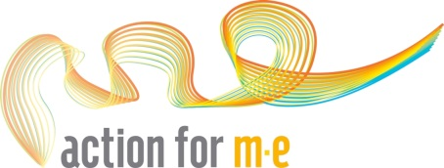
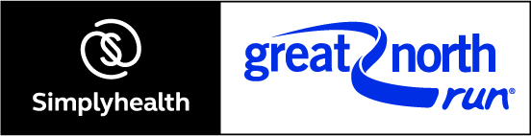

Great North Run 2017

The Great North Run is the premiere event in the Great Run series and is firmly established as Britain’s biggest participation event with a record 55,000 entrants in 2012. Your ears as well as your feet are entertained, as the route plays host to music and bands – making this a lively and dynamic experience for all the senses.

Further information is available on the organiser’s website: http://www.greatrun.org/great-north-run

Event details:

Name: Great North Run
Date: 10 September 2017
Distance: 13.1 miles
Registration fee: £30
Minimum Sponsorship: £350
Contact: fundraising@actionforme.org.uk

What do I Receive?

- Full support from our fundraising team every step of the way
- A full fundraising pack with poster, leaflets and ideas.
- Access to our fundraising materials which include balloons, wristbands and collection tins
- Action for M.E. running vest

If you are interested in being part of our 2017 team please fill in this form and return it:
By Post to: Action for M.E., 42 Temple Street, Keynsham, BS31 1EH.
By Email to: fundraising@actionforme.org.uk

Personal details:
Please write in capitals

First name: Surname:

Date of Birth:

Address:

Mobile number:

Email address:

Does your employer run a matched giving scheme? Yes No
If so please state amount they will match up to:

Please explain why you would like to run for Action for M.E.:
(Continue on new page if necessary)

Please specify your running vest size (unisex sizes):
X-Small / Small / Medium / Large / X-large

How did you hear about Action for M.E. places for the Great North Run?

Sharing your story with your local media helps promote your fundraising efforts, and raise awareness of M.E. Please would you be willing to let us send a press release featuring your story (including your name, age and general location, but not your full address, email or contact number) to journalists? Yes No

In addition to media coverage Action for M.E. can also publicise events on social media. You can tweet us at @actionforme or provide your own Twitter handle below and we can include you in Great North Run publicity posts.
Twitter handle:

Your preferences

I would like to receive a monthly update e-newsletter on Action for M.E.’s work and activities.

I do not wish to receive any appeals for money.

Pledge
I would like to register for a place in the Great North Run 2017 for Action for M.E. I agree to pay the £30 registration fee and pledge to raise a minimum sponsorship of £350

Signed: Date:

If you have any questions please contact our Community Fundraiser on:
0117 937 6626 or e-mail fundraising@actionforme.org.uk

Thank you!

The information you provide will be held securely in accordance with the Data Protection Act 1998 and will be used by Action for M.E. to supply the services which you have requested. Action for M.E. will share information with third parties where it is necessary to ensure your place in the Great North Run 2017, i.e. event organisers.

