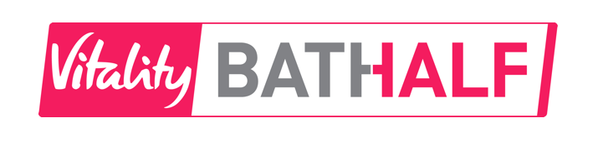
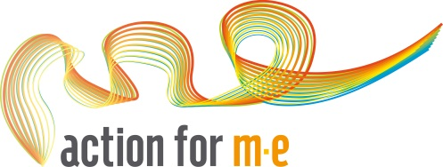
Bath Half Marathon 2017
The Bath Half is one of the UK’s most popular road races and is the largest fundraising event in the South West. The race starts and finishes in Great Pulteney Street in the heart of the World Heritage City of Bath and the course is fast and flat making it suitable for beginners and those looking to beat their personal best. The day itself provides a fantastic atmosphere with spectators lining the streets of Bath to cheer the runners on and samba drummers providing a boost. For further information on the event please visit: www.bathhalf.co.uk

Event details:

Name: Bath Half
Date: Sunday 12 March 2017
Distance: 13.1 miles
Registration fee: £40 (paid to organisers)
Minimum Sponsorship: £200
Contact: fundraising@actionforme.org.uk
Registration deadline: January 29 2017

As a member of the Action for M.E. Bath Half Marathon team you will receive:
- A direct number to our friendly fundraising team
- A full fundraising pack including poster, leaflets and ideas.
- Access to our fundraising materials which include balloons, wristbands and collection tins
- A free running vest
- Our full support every step of the way.

The Bath Half also has a number of blogs on its website which gives participants race day tips and advice. You will have the opportunity to purchase a photo from the official race photographers.
Please note:
- Entrants need to be 17 years or over on race day
- By taking an Action for M.E. bond place you are pledging to raise £175 minimum sponsorship
How do I register for a place?
To enter please fill in the details below and return by
Email to: fundraising@actionforme.org.uk
Post to: Action for M.E., 42 Temple Street, Keynsham, BS31 1EH

To pay your £20 registration fee you can post a cheque with your registration form or to pay by debit or credit card, please call us on 0117 9376626 and we can take payment over the phone. Please note, your place is not confirmed until the registration fee has been paid.
Personal details:
Please write in capitals
First name: Surname:
Date of Birth:
Address:
Mobile number:
Email address:
Expected finish time:
Emergency contact name:
Emergency contact number:
Please specify your running vest size (unisex sizes): Small / Medium / Large / X-large
Please explain why you would like to take part for Action for M.E.:

Sharing your story with your local media helps promote your fundraising efforts, and raise awareness of M.E. Please would you be willing to let us send a press release featuring your story (including your name, age and general location, but not your full address, email or contact number) to journalists? Yes / No
Where did you hear about Action for M.E. Bath Half marathon places?

Your preferences
I would like to receive a monthly update e-newsletter on Action for M.E.’s work and activities.
I do not wish to receive any appeals for money.

Pledge
I would like to register for a place in the Bath Half Marathon 2017 for Action for M.E. I agree to pay the £20 registration fee and pledge to raise a minimum sponsorship of £175
Signed: Date:

If you have any questions contact the fundraising team on 0117 937 6626 or by email at fundraising@actionforme.org.uk

Thank you!

