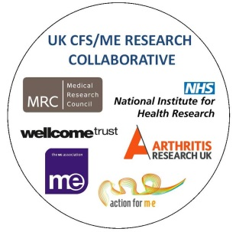
UK CFS/ME Research Collaborative (CMRC)
Membership Form

NAME

EMAIL

UNIVERSITY/
ORGANISATION/
NHS TRUST

ADDRESS

Do you deliver or support CFS/ME research either by: funding research, advising and supporting researchers or as clinicians working with researchers in studies/trials? |  |  |  |  | YES / NO*
If yes, how are you involved in research?

* If you ticked no, would you like to become an Associate Member?  You will be kept updated on CMRC developments and activities. |  |  |  | YES / NO
I confirm that I have read the CMRC overview and agree to work within the values of the CMRC. |  |  |  | YES / NO
I confirm that I am resident/working in the UK |  |  |  | YES / NO
Please tick relevant membership rate |  |  | Student  Associate Member  Professional Member | £15 per year  Free  £20 per year
Signed

Date

Please make cheques payable to ‘CFS/ME Research Collaborative’ and post with your application form to the address below.

For direct payment to the bank please mark as ‘Collaborative Membership’ and make the payment to account number 11415127 and sort code 16-13-18.

Send your application form by email to anna@actionforme.org.uk OR by post to UK CFS/ME Research Collaborative, C/O Action for M.E., 42 Temple Street, Keynsham BS31 1EH.

