

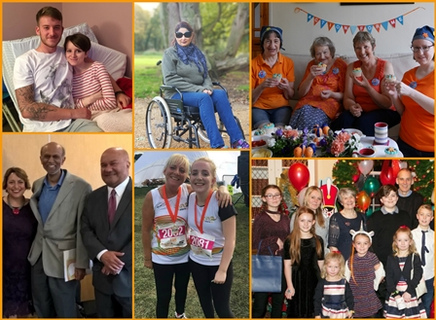
Action for M.E.
Trustee
Application Pack



Thank you for considering joining Action for M.E.

I joined Action for M.E. in September 2012 and am delighted to be working with a staff and volunteer team and Board of Trustees who are passionate, dedicated and determined.

Our 2016 – 2021 strategy, launched at our 2016 AGM and conference, sets out how we meet need now to improve the lives of people with M.E. while taking action to secure change for the future.

A small organisation that regularly punches above its weight, we are leading, with others, a growing community of supporters working to create real change on the scale so urgently needed at a local, national and international level.

I believe that Action for M.E. can, and will, make a major contribution to creating the change that is so desperately needed.

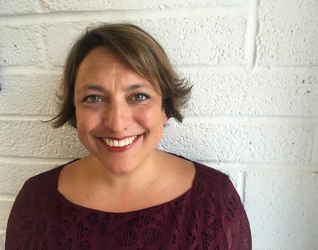

Sonya Chowdhury
Chief Executive

Our values

Shared values are held with high regard in our organisation and reflect how we seek to work with our supporters, partners and other key
stakeholders. They reflect the attitudes, beliefs and behaviour that we value in each other and underpin our whole approach and culture.

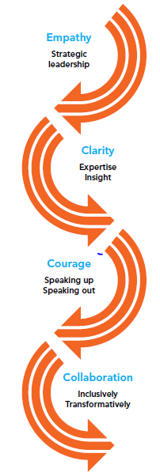

About us

Action for M.E. takes action to end the ignorance, injustice and neglect that people with M.E. face day-in, day-out.

The charity was founded by Sue Finlay in 1987 and since then has been working tirelessly to tackle the inequality experienced by people with M.E.

M.E. (Myalgic Encephalomyelitis) is a chronic, neurological illness affecting an estimated 250,000 adults and children in the UK. It may be diagnosed as Chronic Fatigue Syndrome (CFS, or M.E./CFS).

People with M.E. experience severe, persistent fatigue associated with post-exertional malaise, the body’s inability to recover after expending even small amounts of energy, leading to a flare-up in symptoms.

Even in its so-called mildest form, M.E. can have a significant impact on an individual’s life, and not just on their health. A lack of understanding and awareness about M.E. means patients can experience disbelief, and even discrimination, from friends, family, health and social care professionals and employers.

Our vision

A world without M.E.

Our mission

Empowering people with M.E. to fulfil their potential and secure the care and support they need, while working towards a greater understanding of the illness and ultimately a cure.

Our people

President
Clare Francis MBE

Vice President
Martin Arber

Patrons
Lord David Puttnam CBE
Lord Melvyn Bragg
Julie Christie
Professor Anthony J. Pinching

Chair of Board of Trustees
Jonah Grunsell

Vice Chair
Vacant

Board of Trustees
We are an organisation led by people affected by M.E. for people affected by M.E. We aim to have a minimum of 51% of our Trustees who have, or have had, M.E. themselves.

Our Trustees are unpaid and meet at least four times a year and many sit on one of our four sub-committees. The Board meeting location alternates between London and Keynsham.

We have a staff team of 22 (17 FTE) and approximately 70 volunteers who support our work in a number of different ways.

Our head office is in Keynsham (between Bath and Bristol) and we also have staff in Scotland, Milton Keynes, London and Geneva.

Over the next five years, our purpose is to end the ignorance, injustice and neglect experienced by people with M.E.

People with M.E. are at the heart of everything we do. We asked and we listened, and have identified a number of challenges that continue to exist for people affected by M.E.
Everything we do over the next five years will be in service of achieving three goals, which we call our strategic touchstones.

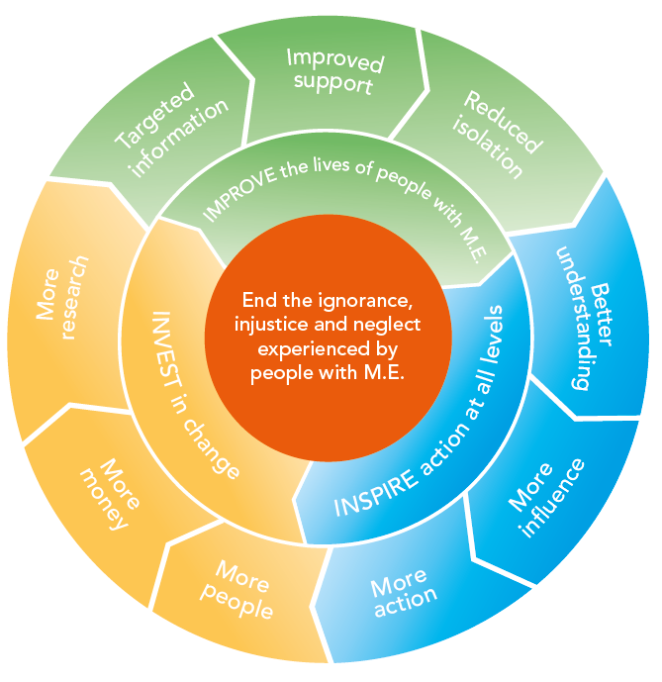

By collaborating with those who share our vision and purpose, we can make the most of the resources available to us.
Around 50% of our activities will directly focus on targeting information, improving support and reducing isolation to IMPROVE the lives of people with M.E. To be as effective as possible, 30% of our activities will focus on facilitating more action, more influence and better understanding of M.E. to INSPIRE action at all levels; and 20% of our activities will be focused on bringing more research, more money and more people into the field to INVEST in change.

Trustee role description

The duties of the Trustee are:

1. To ensure that Action for M.E. complies with its Memorandum and Articles of Association, charity law, company law and any other relevant legislation or regulations.

2. To ensure that Action for M.E. pursues its charitable objects as defined in its Memorandum of Association.

3. To ensure Action for M.E. applies its resources exclusively in pursuance of its objectives.

4. To contribute actively to the Board of Trustees role in establishing a clear and shared vision for Action for M.E., giving firm strategic direction, setting overall policy, defining goals, setting targets and evaluating performance against the agreed targets.

5. To act in the interests of Action for M.E. and for people with M.E. in general.

6. To safeguard the good name and values of Action for M.E.

7. To ensure the effective and efficient administration of Action for M.E.

8. To ensure the financial stability of Action for M.E.

9. To protect and manage the property of Action for M.E. and to ensure the proper investment of charity funds.

10. To appoint the Chief Executive and to monitor his or her performance and determine his or her remuneration.

11. In addition to the above statutory duties of all Trustees, each Trustee should use any specific knowledge or experience they have to help the Board of Trustees reach sound decisions.

12. To represent Action for M.E. as appropriate.

Trustee person specification

All Trustees must demonstrate:

- A commitment to the organisation, its cause and demonstrate an understanding of M.E. and its impact.

- A willingness to devote the necessary time and effort.

- Strategic vision.

- Good, independent judgment.

- An ability to think creatively.

- A willingness to speak their mind.

- An understanding and acceptance of the legal duties, responsibilities and liabilities of Trusteeship.

- An ability to work effectively as a member of a team.

- A willingness to participate in at least one sub-committee, as appropriate.

- A commitment to working within Action for M.E.’s values and principles of working, including Nolan’s ‘Seven Principles of Public Life’:

- Selflessness
- Integrity
- Objectivity
- Accountability
- Openness
- Honesty
- Leadership

More information

Trustees receive a full induction and there are bi-annual development days for Trustees with the CEO and Senior Leadership Team. We also provide a Trustee Handbook and a copy of NCVO’s ‘Good Trustee Guide’.

To ensure that the Board functions effectively, Trustees are expected to attend as many meetings as possible. We recognise that some people will not be able to travel due to M.E. therefore attendance and availability may be sporadic; where it aids accessibility teleconferencing will be possible although this may not be appropriate for some people.

There are four sub-committees of the Board of Trustees. It is anticipated that Trustees will participate in at least one sub-committee:
- Audit, Finance and Fundraising Committee
- Research Panel
- Policy Group
- Remunerations and Nominations Committee.

How to apply

If you are interested in becoming a Trustee, please submit
- your CV identifying how you meet the person specification and
- the completed Equal opportunities monitoring and information form below
- a covering letter outlining why you would like to become a Trustee and how you meet the person specification outlined above.

Please also indicate any reasonable adjustments that you may require to enable us to provide a good recruitment process with you.

Timetable

Closing date for applications | 9am Tuesday 29 May 2018
Interviews with CEO, Chair and Trustee | Tuesday 5 June (London) or Wednesday 27 June 2018 (Keynsham)
Opportunity for candidates to observe Board meeting and meet other Trustees | Thursday 5 July (Keynsham) or  Thursday 18 October 2018 (London)
Supporting members’ vote | August to October 2018
Action for M.E. AGM | Wednesday 28 November 2018

For more information, or to submit an application, please contact Anna Whitson at Action for M.E., 42 Temple Street, Keynsham BS31 1EH. Tel: 0117 927 9551.
Email: anna@actionforme.org.uk

Equal opportunities monitoring and information form

Action for M.E. is committed to its equal opportunities policy. This means that we shall treat all applicants and employees fairly and equally, irrespective of race, colour, age, ethnic or national origins, sex, religious belief, gender reassignment, trade union activity, marital status, sexual orientation or disability. The information you provide here is confidential, and will be used for monitoring purposes only. It will not be seen by the short-listing or interview panels. Please return this form with your application.

Please tick the boxes that apply to you:

Age group:  - 21 – 30  - 31 – 40  - 41 – 50  - 51 – 65  - 65+  - Do not wish to answer | Gender:  - Male  - Female  - Do not wish to answer
Ethnic Origin:  White  - British  - Irish  - Other European  - Other…………………………… | Asian  - Asian British  - Bangladeshi  - Indian  - Pakistani
Black  - African  - Black British  - Caribbean  - Other…………………………….. | Chinese  - Chinese  Other  - Other……………………………
Mixed race  - White and Asian  - White and Black African  - White and Black Caribbean | - White and Chinese  - Other……………………………..

Equality Act 2010

The Equality Act protects people from unlawful legislation. If you tell us that you have disability, we will make reasonable adjustments to your working environment and your work practices, if it is reasonable for us to do so.

You’re disabled under the Equality Act 2010 if you have a physical or mental impairment that has a ‘substantial’ and ‘long-term’ negative effect on your ability to do normal daily activities.

Do you consider yourself to have disability? | - Yes*  - No

*If yes, please indicate which category best describes your disability:
- Hearing impairment
- Visual impairment
- Speech impairment
- Mobility impairment
- Physical co-ordination (eg. manual dexterity/muscle control)
- Reduced physical capacity (eg. severe pain, lack of strength, breath or stamina)
- Learning difficulties
- Mental illness
- Other……………………………………………………………………………...……………………………………………………………………………………………….

Advertising and publicity
Please tell us how you heard of this vacancy:

- Website (please specify)………………………………………………………
- Newspaper (please specify)……………………………………………………….
- Other (please specify)………………………………………………………

For more information

Visit our Online M.E. Centre at www.actionforme.org.uk where you can find out more about M.E. and the work we do or contact Action for M.E. on 0117 927 9551.

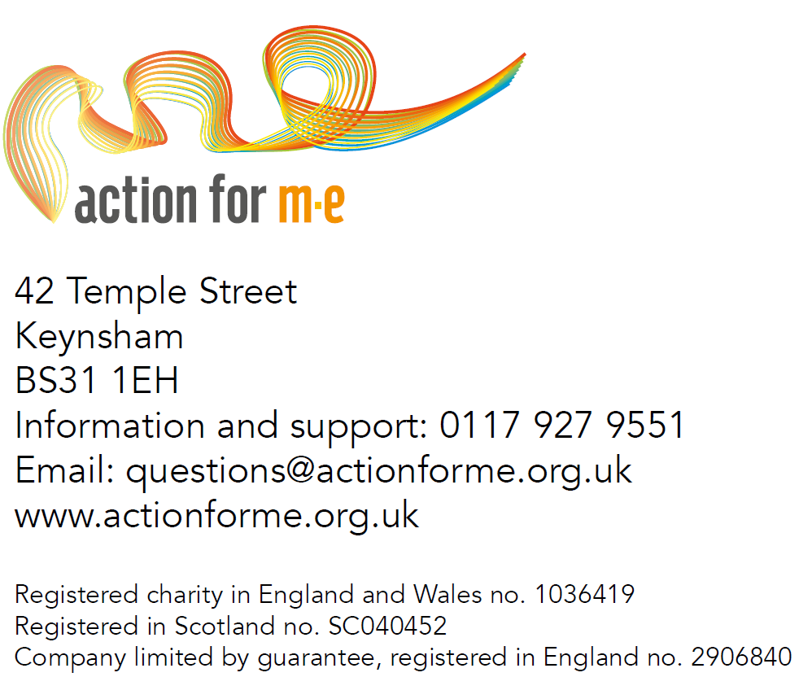
Pictured on the cover, clockwise from top left: Great South 2017 runner Ben Brockway and his sister Laura; Action for M.E. supporter Sharon Blake; Elizabeth Keyworth and friends having a fundraising tea party; Sonya Chowdhury, Chief Executive, with Profs Avindra Nath and Jose Montoya at UK CFS/M.E. Research Collaborative conference 2017; fundraisers Sally Kendrick and her daughter Lauren; Mary-Jane Willows, Head of Children’s Services, with children and families at 10 Downing Street Christmas party 2017.

