Boredom Busters
By Jessica Morgan
Hello everyone,
My name’s Jess and this is my first ever article for Cheers! Like all the people reading this I have M.E., and I know how brain-numbingly boring it can be, so here are some quick and easy ideas how to entertain yourself.
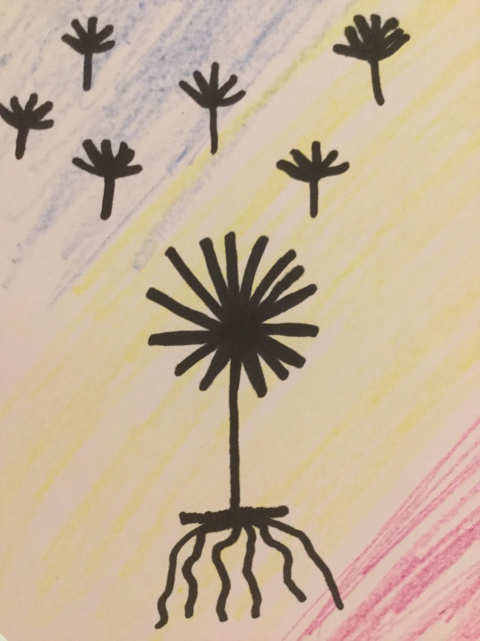
One Pencil, One Pen Drawing
What you need to do for this particular activity is to grab a piece of white paper (scrap/lined/plain) and choose any coloured pencil you desire.
I would deeply recommend a black pen/marker as your choice of pen but blue works as well.
Now once you have got all of that together, you are going to need to find something to draw; for example, a flower, an octopus, an owl, a crab, a cupcake or a fairy? Pretty much anything with an interesting outline will work.
You could use a piece of coloured paper instead of a coloured pencil and white paper if you wanted.
Now you are going to need to think what size your black/blue shadow drawing’s going to be and whatever size you choose you’ll need to make sure that your colouring pencil background/ coloured paper is larger than whatever it is that you choose to draw.
*Quick message, if you are choosing to use coloured paper ignore step one.*
Step one. Get your coloured pencil and begin to rapidly colour in your paper, making sure that the area coloured in is larger than whatever you are going to draw.
Step two. Once you have coloured in your specified area, start to trace whatever it is you’ve chosen to draw with your black/blue pen, making sure you are only drawing the outline of the picture.
Step three. After you’ve drawn your chosen “object” simply colour it in with black/dark blue pen and voila you are DONE!

Random Ideas 101
Here is a list of random ideas of things to do when you’re bored:
- Listen to an audio book/story cd.
- Listen to or watch a TV programme or film that you’ve already watched before or if you’re feeling a bit better than usual watch a new TV programme or film.
- Read a book.
- Draw some doodles.
- Watch an ASMR (Autonomous Sensory Meridian Response) video. These relaxing videos became very popular recently and involve short clips of for example; gentle whispering or quiet repetitive sounds such as someone turning the pages of a book or brushing their hair.

I hope you found these ideas useful and attempt to try some. Finally, here’s a little life hack for you that I’ve found helpful:
Office Chair Assistance
On the really bad days, everything feels so rubbish often I feel like I can’t even get out of bed. Well, I have a pretty good hack for that so here it is.
Every night before you go to bed, if you have an office chair that spins in your room, put it next to your bed, with all the things you think you might need for the next day. Therefore, if you feel bad the next day, your things (e.g Hair brush, deodorant, maybe even a puzzle), are there right beside you.
There is another use to the office chair though, if you feel unable to stand, simply transfer your things on to the floor and shuffle on to the chair, easily spinning yourself round and encouraging your body to get up. (But if you can’t get up, don’t worry.)
Written by Jessica Morgan Age 12.

