10 Famous People with M.E./CFS
By Jessica Kealy
M.E./CFS has been around far longer than the name itself and therefore it has been speculated that some of these famous people may possibly have had the illness. Of course, at the time their ill health was put down to other things. Let’s start with the revolutionary nurse whose birth date… well, let’s just put it this way, it’s no coincidence that it falls on the same day as M.E. Awareness Day.
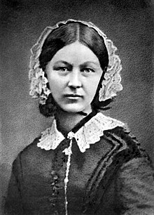
FLORENCE NIGHTINGALE
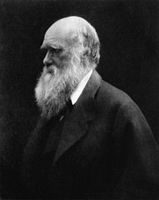
Yes, this may come as a surprise, but Florence Nightingale is speculated to have suffered from M.E./CFS in her later years. Other possible conditions such as depression or a severe form of brucellosis have also been suggested, but Florence Nightingale’s birthday is now the day we celebrate M.E. Awareness Day. Personally, I like to think that perhaps this pioneering nurse did have M.E./CFS and yet was still able to achieve so much… although I have to admit that this may never be proven. Still, nice to think about, right?
CHARLES DARWIN
Again this is only speculation and there are a lot of other possible conditions which could have caused the symptoms (malaise, vertigo, dizziness, vomiting, cramps, bloating, headaches, severe tiredness and tinnitus) that Darwin suffered from for forty years after coming back from his travels to South America and the Pacific Islands. He remained undiagnosed for all of his life, but a few medical journals suggest that he may have suffered from M.E./CFS.
MICHELLE AKERS
Michelle Akers was a footballer (or should I say soccer player?) back in the 90s, and she overcame M.E./CFS to become arguably the greatest American women’s soccer player of all time. When asked about her illness, she responded with this: “The irony of the illness [is], the harder you work, the more it drags you down, the more it disables you.’’ Despite this she became one of only two women to be listed in the FIFA 100, a list of the greatest living footballers in the world, selected by Pelé and published for FIFA’s centenary in 2004.
KEITH JARRETT
Keith Jarrett, the renowned jazz pianist, was diagnosed with M.E./CFS in 1996. His M.E./CFS meant that he couldn’t even listen to music for a period of time, let alone play the piano. “I didn’t know if I would ever play again. It’s hard to describe. It’s almost like the disease made it possible to deal with the skeleton instead of the surface, you know — just the heart of things, because there was no energy for more than that.”
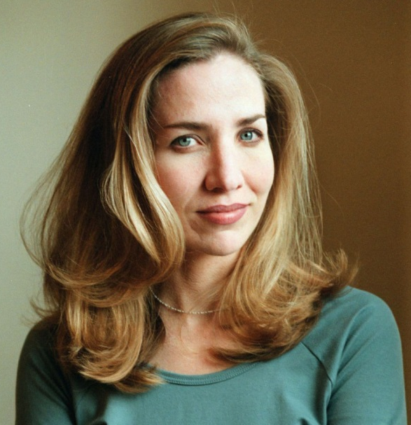
LAURA HILLENBRAND
Laura Hillenbrand is a famous author, and begun suffering from M.E./CFS in 1987. Hillenbrand recalls waking up to find that one day she couldn’t get out of bed, and eventually her M.E./CFS forced her to drop out of college. Her lymph nodes became inflamed, her body was unable to keep a steady temperature, and she lost significant amounts of weight. She said: “It’s like you go to another place, like you’re not on this planet anymore.”
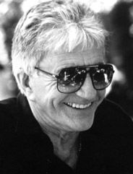
BLAKE EDWARDS
Probably best remembered for the film Pink Panther, Blake Edwards (AKA William Blake Crump) was a filmmaker who suffered from M.E./CFS for 15 years. Edwards described it as “the flu that would never go away”. After directing a new film, Edwards reported being unable to remember any of his time directing it due to his M.E./CFS growing more severe. He also spoke in a 2000 documentary on M.E./CFS when he said: “The desperation was enormous… [Comedy] saved me from [ME/CFS].”
EMMA BLACKERY
Emma Blackery is a British singer-songwriter who has a YouTube following of over 1.5 million. She has suffered from M.E./CFS for quite a few years.

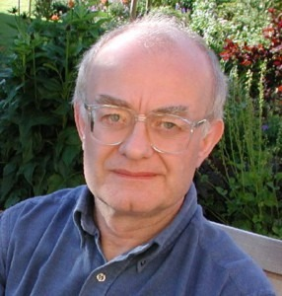
JOHN RUTTER
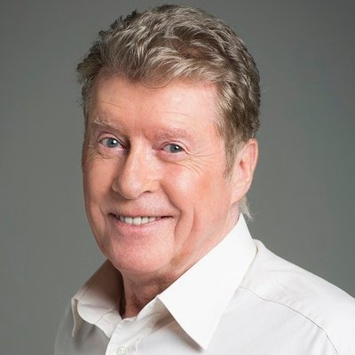
John Rutter is one of the most successful living composers, yet he struggled with M.E./CFS for seven years. He spoke about his experience with the illness in the newspaper The Spectator, arguing that it was real. Here’s what he said: “M.E. — myalgic encephalomyelitis, alias post-viral fatigue syndrome or yuppie flu, is not [a fake illness]. It’s an unpleasant physical illness: it ruined seven years of my life.”
MICHAEL CRAWFORD
An English actor, comedian and singer, Crawford became ill with M.E./CFS back in 2004. In the midst of performing in an Andrew Lloyd Weber musical he gained a diagnosis… well, after a while. “Teams of doctors were called in to try and find out why I was so completely exhausted, depleted and unable to return to work. I had brain and body scans, and virtually every test known to man before eventually discovering that I was suffering from the post-viral condition M.E.”
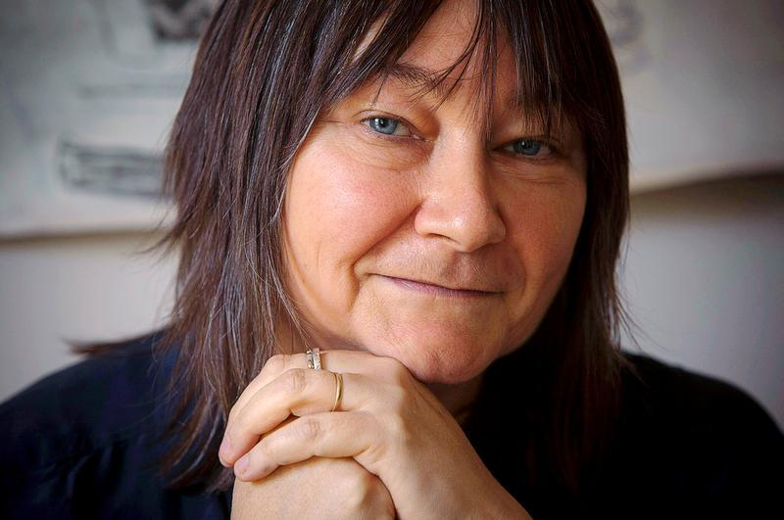
ALI SMITH
Ali Smith is a former academic and an award-winning novelist. She originally became ill with M.E./CFS at the age of 27. For M.E. Awareness Day last year, Smith wrote about her experience with ME/CFS. “M.E./CFS is medically underestimated and marginalised, as pretty much everyone who has it or who’s ever had it knows. It’s misunderstood, it needs more research, money and attention, in the case of both those who suffer from it and those who work to discover its sources. This is urgent.”

