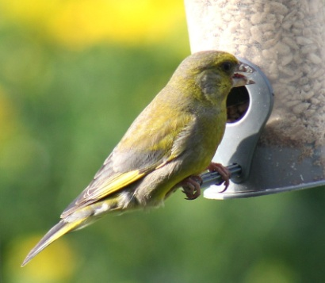
Garden Birdwatch
Spend an hour watching your garden and use our bird counting checklist to record the birds you see. Record the highest number of each bird species that you see at the same time (to avoid counting the same bird twice) and then compare notes in the forum – what did you see?
Here is our checklist of common garden birds to keep an eye out for – although maybe you’ll be the one to spot a rare species. I saw a most unusual bird (of the plastic variety) when I tried!
Common Garden Birds Checklist:
Blackbird
Blue Tit
Chaffinch
Coal Tit
Collared Dove
Dunnock
Goldfinch
Great Tit
Greenfinch
House Sparrow
Long-Tailed Tit
Magpie
Robin
Starling
Woodpigeon
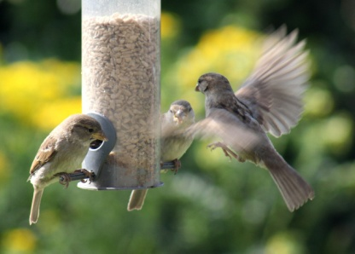
Try putting out some food in bird feeders or on a bird table to encourage the birds to come and visit you during your hour of birdwatching. Possibilities include: sunflower hearts, suet balls, dry porridge oats, sultanas, currants, mild grated cheese or cake crumbs.
It’s a good idea to leave them something to drink too, some water in a shallow bowl is ideal.
Other wildlife to look out for:
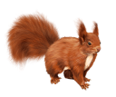
Grey squirrel
Red squirrel
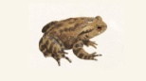
Hedgehog
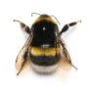
Common toad
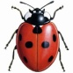
Bumblebee
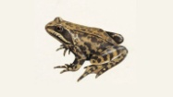
7 spot Ladybird
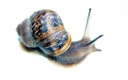
Common frog
Common snail
Butterflies:
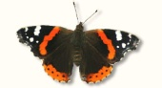
Peacock
Red Admiral
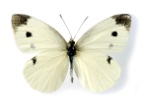
Holly Blue
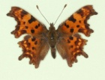
Cabbage White
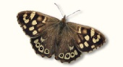
Comma
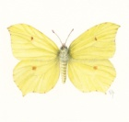
Speckled Wood
Brimstone

