

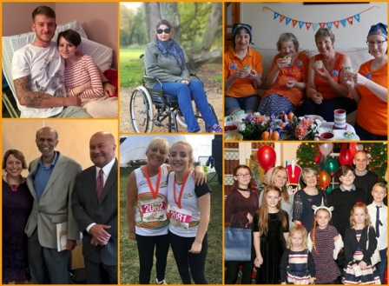
Action for M.E.
Policy and Engagement Officer
Application pack



Thank you for considering joining Action for M.E.

I joined Action for M.E. in September 2012 and am delighted to be working with a staff and volunteer team and Board of Trustees who are passionate, dedicated and determined.

Our 2016 – 2021 strategy, launched at our 2016 AGM and conference, sets out how we meet need now to improve the lives of people with M.E. while taking action to secure change for the future.

A small organisation that regularly punches above its weight, we are leading, with others, a growing community of supporters working to create real change on the scale so urgently needed at a local, national and international level.

In April 2017, we launched our Children’s Services after joining forces with national children’s charity, the Association of Young People with M.E. This provides an exciting opportunity to raise more money to reach more people and raise much needed awareness and understanding

I believe that Action for M.E. can, and will, make a major contribution to creating the change that is so desperately needed.



Sonya Chowdhury
Chief Executive
Our values

Shared values are held with high regard in our organisation and reflect how we seek to work with our supporters, partners and other key
stakeholders. They reflect the attitudes, beliefs and behaviour that we value in each other and underpin our whole approach and culture.

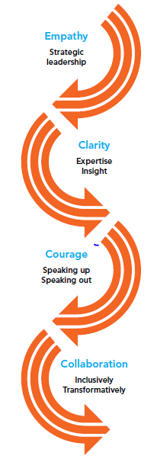

About us

Action for M.E. takes action to end the ignorance, injustice and neglect that people with M.E. face day-in, day-out.

The charity was founded by Sue Finlay in 1987 and since then has been working tirelessly to tackle the inequality experienced by people with M.E.

M.E. (Myalgic Encephalomyelitis) is a chronic, neurological illness affecting an estimated 250,000 adults and children in the UK. It may be diagnosed as Chronic Fatigue Syndrome (CFS, or M.E./CFS).

People with M.E. experience severe, persistent fatigue associated with post-exertional malaise, the body’s inability to recover after expending even small amounts of energy, leading to a flare-up in symptoms.

Even in its so-called mildest form, M.E. can have a significant impact on an individual’s life, and not just on their health. A lack of understanding and awareness about M.E. means patients can experience disbelief, and even discrimination, from friends, family, health and social care professionals, employers and teachers.

Our vision

A world without M.E.

Our mission

Empowering people with M.E. to fulfil their potential and secure the care and support they need, while working towards a greater understanding of the illness and ultimately a cure.

Our people

President
Clare Francis MBE

Vice President
Martin Arber

Patrons
Lord David Puttnam CBE
Lord Melvyn Bragg
Julie Christie
Professor Anthony J. Pinching
Alan Cook CBE

Chair of Board of Trustees
Jonah Grunsell

Vice Chair
Vacant

Board of Trustees
We are an organisation led by people affected by M.E. for people affected by M.E. We aim to have a minimum of 51% of our Trustees who have, or have had, M.E. themselves.

Our Trustees are unpaid and meet at least four times a year and many sit on one of our four sub-committees. Board meeting location alternates between London and Keynsham.

We have a staff team of 20 (16.9 FTE), four sessional staff and approximately 70 volunteers who support our work in a number of different ways.

Our head office is in Keynsham (between Bath and Bristol) and we also have a small number of staff and volunteers in Scotland, a staff member in London. We also commission international advocacy work which is led by a colleague based in Geneva.

Over the next five years, our purpose is to end the ignorance, injustice and neglect experienced by people with M.E.

Children, young people and adults with M.E. are at the heart of everything we do. We asked and we listened, and have identified a number of challenges that continue to exist for people affected by M.E.
Everything we do over the next five years will be in service of achieving three goals, which we call our strategic touchstones.

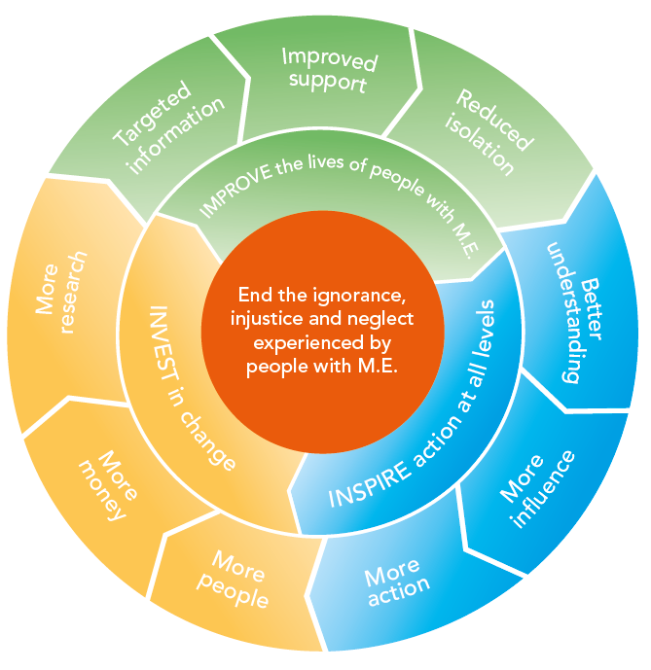

By collaborating with those who share our vision and purpose, we can make the most of the resources available to us.
Around 50% of our activities will directly focus on targeting information, improving support and reducing isolation to IMPROVE the lives of children, young people and adults with M.E. To be as effective as possible, 30% of our activities will focus on facilitating more action, more influence and better understanding of M.E. to INSPIRE action at all levels; and 20% of our activities will be focused on bringing more research, more money and more people into the field to INVEST in change.

Job summary

Job title | Policy and Engagement Officer
Responsible to | Head of Communications and Engagement
Responsible for | Policy volunteers and/or interns
Salary | £24,000
Hours of work | Full time (35 hours per week)
Annual leave | 30 days + 8 bank holidays per year pro rata
Location | Keynsham office

1. Job purpose

You will play a vital role in developing a programme of UK policy and engagement activities at local, national and international level, led by the voices and experiences of children, young people and adults living with M.E., focusing on issues specifically related to health, employment, education, social care and welfare benefits, to maximise impact and influence.

2. Key duties

2.1 Policy and engagement

- Consult with children, young people and adults living with M.E. to inform the direction of our policy and engagement work.
- Build relationships with key stakeholders who can help us achieve our policy and engagement goals, including but not limited to parliamentarians, press and media contacts, and senior decision-makers and professionals working in health, employment, education, social care and welfare benefits.
- Develop a strategy to support children, young people and adults living with M.E. to effectively engage with their MP and other relevant decision-makers.
- Liaise with local M.E. support groups to enhance influence and increase understanding at a local level.
- Keep up-to-date with key policy issues affecting to children, young people and adults living with M.E., and Action for M.E.’s position.
- Engage with relevant consultations and inquiries led by the UK and devolved governments, and professional bodies such as the GMC and CQC.
- Act as Action for M.E.’s representative to collaborate and build relationships with organisations that share our goals, including Forward M.E. and the Disability Benefits Consortium, and contribute to joint pieces of work.
- Produce inspiring, engaging content that demonstrates the difference we make, for communications channels including our Online M.E. Centre, social media channels, membership magazine, and press releases.

2.2 Working with others

- Work with our Head of Communications and Engagement to develop a nation-specific policy and engagement plan, targeting key stakeholders including decision-makers at all levels, and professionals working in health, employment, education, social care and welfare benefits.
- Support our Head of Children and Young People’s Services to increase relevant knowledge and understanding of key decision-makers/professionals whose work impacts children, young people and families living with M.E.
- Support our Head of International Advocacy to advocate for the needs of people with M.E. at World Health Organisation level, including engaging with the International Alliance for M.E.
- Support our Project Coordinator in Scotland to engage with and influence relevant policy matters in Scotland.
- Line-manage policy volunteers and/or interns, supporting them to set and achieve performance objectives through regular 1-2-1 meetings and annual appraisals.

2.3 Other key accountabilities

- Undertake any other duty within your ability and within reason, as may be required from time to time, at the direction of your line manager. This includes phone duty cover.
- Act as an advocate for the charity and its work, and contribute to raising the profile of M.E.

3 Person specification

3.1 Qualifications

- Educated to degree level, or proven transferable and relevant experience

3.2 Experience and knowledge

- Demonstrable experience in a policy-focused role, ideally within a charity
- Demonstrable experience of managing interns or volunteers
- Demonstrable experience of parliamentary engagement
- Demonstrable experience of engaging face-to-face, by phone and online with stakeholders at all levels
- Knowledge and understanding of the impact of long-term health conditions
- Knowledge of relevant policy and legislation
- Knowledge of government processes and systems

3.3 Skills and behaviours

- Strong research and analytical skills
- Strong MS Office skills including Word, Excel, databases and web-related programmes and software
- Excellent planning skills with the ability to work methodically, managing and prioritising a varied workload
- Excellent written and verbal communication and interpersonal skills, including a good telephone manner
- Able to use own initiative, work independently and to work well in a team
- Able to develop and maintain networks with external stakeholders
- Able to speak confidently in a range of public settings, on behalf of the charity
- Able to effectively report on complex and detailed quantitative and qualitative data for targeted audiences
- Able to produce effective, engaging copy for targeted audiences
- Able to develop systems, maintaining records and meeting policy and procedure requirements
- Able to support and motivate volunteers and/or interns
- Able and willing to travel regularly in the UK, usually to London, for meetings and events, with occasional travel to Geneva

3.4 Attitudes and values

- Proactive
- Enthusiastic
- Inclusive
- Acts with integrity
- Adaptable and flexible
- Calm and compassionate
- Resilient and resourceful

3.5 Key competencies

- Confident communicator
- Strategic thinker
- Outcomes-focused

Terms and conditions

Outlined below are some of the main terms and conditions of employment relevant to all employees of Action for M.E.

1. Probation
All posts are subject to three months’ probation. During this probationary period, either party may give the other one week’s notice in writing to terminate the employment. After successful completion of the probationary period, the notice stated on your contract of employment will apply.

2. Annual leave
The holiday year runs from 1 April to 31 March. In each holiday year in addition to bank and statutory holidays the holiday entitlement for a full time employee is 30 days (includes 3-4 days to be taken at Christmas as directed when the office is shut).

3. Pension scheme
Action for M.E. operates a group pension scheme on an auto-enrolment basis. All employees will join the scheme on the completion of the probationary period unless they choose to opt-out. Action for M.E. will pay a pension contribution which is currently 3% of salary. Action for M.E. will not pay into a personal pension scheme

4. Salary payment
Salaries are paid in arrears on the last working day of each month, by direct credit transfer into a bank or building society.

5. Flexibility
This post may require working outside of normal office hours and travel to attend meetings and events within the UK, including occasional overnight stays.

Application timetable

Deadline for applications | 9am Thursday 2 August
Short list meeting | Thursday 2 August
Interviews | Thursday 9 August

For more information, or to submit an application, please contact Anna Whitson at Action for M.E., 42 Temple Street, Keynsham BS31 1EH. Tel: 0117 937 6637.
Email: anna@actionforme.org.uk

 | Application form  for the post of  Policy & Engagement Officer

Please PRINT and use black ink if not completing electronically. This form must be completed in full. Any additional information submitted (eg. CV) will not be considered in the shortlisting process.

Personal details

Surname | First name(s) | Title
Address

Email address

Office hours telephone number | Other hours telephone number | Mobile number
Do you need a work permit for permanent employment in the UK? YES / NO |  | If so, do you have one?  YES / NO

Please provide education history and qualifications

Name of school, college or university | Date  from – to – | Qualifications gained
Please provide full work history (please ensure you account for any gaps in employment. Only provide a very brief summary of responsibilities as this will not be taken into account in scoring your application).

Job title and responsibilities | Organisation/Employer | Date  from – to – | Reason for leaving

Please provide current salary details (or last post if not in current employment) £_______

Please describe, in no more than two pages, why you want this role and how you fit all aspects of the person specification set out in this application pack

Referees

Please note that a verbal reference will be picked up for the successful candidate prior to making a verbal offer to them
Name  Address  Telephone  E-mail address:  Relationship to you | Name  Address  Telephone  E-mail address:  Relationship to you

Declaration

I declare that all the information I have given on this application form is true to the best of my knowledge and belief. I understand that my application may be rejected and/or that I may be dismissed if I have given information which is found to be false.

Signed…………………………………………………………..

Date……………………………………………………………...

Please return this form to anna@actionforme.org.uk

Data Protection Act 1998
Information provided on this application form will be treated as confidential and held in secure conditions. Access will be restricted to those involved in the recruitment and selection process. Data you provide may be copied for use in the recruitment process and once this is completed, the information will be stored for a maximum of 12 months and then destroyed. If you are the successful candidate, relevant information will be taken from your application and transferred to your personal file. We are unable to process your application unless we can use your personal data. By signing and submitting this form, you are giving your consent to the processing of your data in the ways described.
Equal opportunities monitoring and information form

Action for M.E. is committed to its equal opportunities policy. This means that we shall treat all applicants and employees fairly and equally, irrespective of race, colour, age, ethnic or national origins, sex, religious belief, gender reassignment, trade union activity, marital status, sexual orientation or disability. The information you provide here is confidential, and will be used for monitoring purposes only. It will not be seen by the short-listing or interview panels. Please return this form with your application.

Please tick the boxes that apply to you:

Age group:  - 21 – 30  - 31 – 40  - 41 – 50  - 51 – 65  - 65+  - Do not wish to answer | Gender:  - Male  - Female  - Do not wish to answer
Ethnic Origin:  White  - British  - Irish  - Other European  - Other…………………………… | Asian  - Asian British  - Bangladeshi  - Indian  - Pakistani
Black  - African  - Black British  - Caribbean  - Other…………………………….. | Chinese  - Chinese  Other  - Other……………………………
Mixed race  - White and Asian  - White and Black African  - White and Black Caribbean | - White and Chinese  - Other……………………………..

Equality Act 2010

The Equality Act protects people from unlawful legislation. If you tell us that you have disability, we will make reasonable adjustments to your working environment and your work practices, if it is reasonable for us to do so.

You’re disabled under the Equality Act 2010 if you have a physical or mental impairment that has a ‘substantial’ and ‘long-term’ negative effect on your ability to do normal daily activities.

Do you consider yourself to have disability? | - Yes*  - No

*If yes, please indicate which category best describes your disability:
- Hearing impairment
- Visual impairment
- Speech impairment
- Mobility impairment
- Physical co-ordination (eg. manual dexterity/muscle control)
- Reduced physical capacity (eg. severe pain, lack of strength, breath or stamina)
- Learning difficulties
- Mental illness
- Other……………………………………………………………………………...……………………………………………………………………………………………….

Advertising and publicity
Please tell us how you heard of this vacancy:

- Website (please specify)………………………………………………………
- Newspaper (please specify)……………………………………………………….
- Other (please specify)………………………………………………………

For more information

Visit our Online M.E. Centre at www.actionforme.org.uk where you can find out more about M.E. and the work we do or contact Action for M.E. on 0117 927 9551

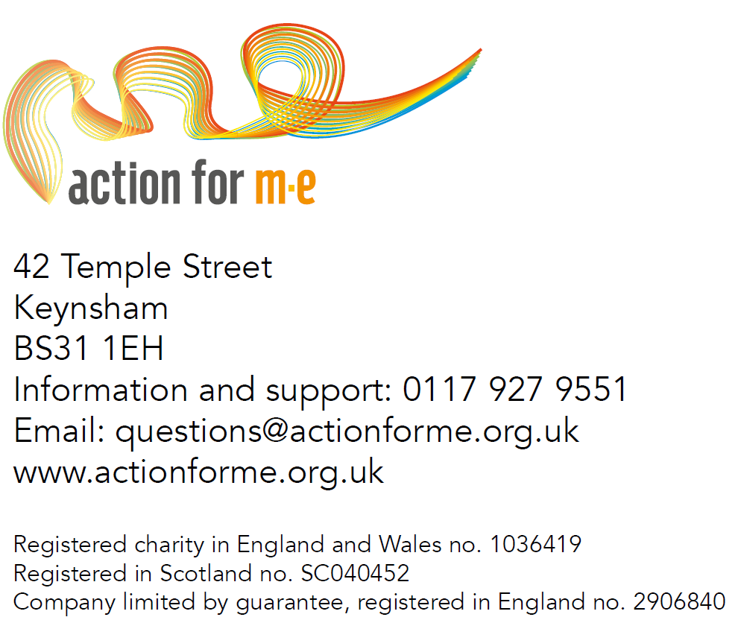
Pictured on the cover, clockwise from top left: Great South 2017 runner Ben Brockway and his sister Laura; Action for M.E. supporter Sharon Blake,; Elizabeth Keyworth and friends having a fundraising tea party; Sonya Chowdhury, Chief Executive, with Profs Avindra Nath and Jose Montoya at CMRC research conference 2017; Fundraisers Sally Kendrick and her daughter Lauren; Mary-Jane Willows, Head of Children’s Services, with children and families at 10 Downing Street Christmas party 2017

