Action for M.E.
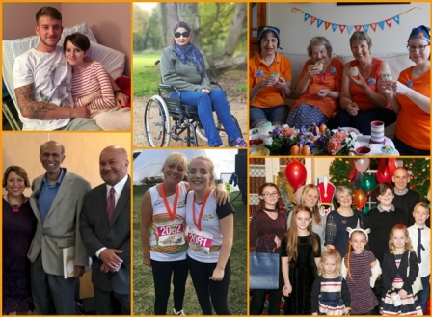
Chair of Board of Trustees
Application Pack

Thank you for considering joining Action for M.E.

I joined Action for M.E. in September 2012 and am delighted to be working with a staff and volunteer team and Board of Trustees who are passionate, dedicated and determined.

Our 2016 – 2021 strategy sets out how we meet need now to improve the lives of people with M.E. while taking action to secure change for the future.

A rapidly growing organisation that regularly punches above its weight, we are leading, with others, a growing community of supporters working to create real change on the scale so urgently needed at a local, national and international level.

In 2017 we launched our Children’s Services after joining forces with the national children’s charity, AYME, and this year we have launched our Advocacy Service in the Midlands and South West.

I believe that Action for M.E. can, and will, make a major contribution to creating the change that is so desperately needed.

Sonya Chowdhury
Chief Executive

Our values

Shared values are held with high regard in our organisation and reflect how we seek to work with our supporters, partners and other key
stakeholders. They reflect the attitudes, beliefs and behaviour that we value in each other and underpin our whole approach and culture.

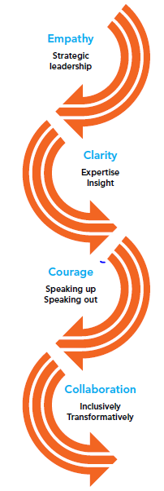

About us

Action for M.E. takes action to end the ignorance, injustice and neglect that people with M.E. face day-in, day-out.

The charity was founded by Sue Finlay in 1987 and since then has been working tirelessly to tackle the inequality experienced by people with M.E.

M.E. (Myalgic Encephalomyelitis) is a chronic, neurological illness affecting an estimated 250,000 adults and children in the UK. It may be diagnosed as Chronic Fatigue Syndrome (CFS, or M.E./CFS).

People with M.E. experience severe, persistent fatigue associated with post-exertional malaise, the body’s inability to recover after expending even small amounts of energy, leading to a flare-up in symptoms.

Even in its so-called mildest form, M.E. can have a significant impact on an individual’s life, and not just on their health. A lack of understanding and awareness about M.E. means patients can experience disbelief, and even discrimination, from friends, family, health and social care professionals, employers and teachers.

Our vision

A world without M.E.

Our mission

Empowering people with M.E. to fulfil their potential and secure the care and support they need, while working towards a greater understanding of the illness and ultimately a cure.

Our people

President
Clare Francis MBE

Vice President
Martin Arber

Patrons
Lord David Puttnam CBE
Lord Melvyn Bragg
Julie Christie
Professor Anthony J. Pinching
Alan Cook CBE

Chair of Board of Trustees
Jonah Grunsell

Vice Chair
Vacant

Board of Trustees
We are an organisation led by people affected by M.E. for people affected by M.E. We aim to have a minimum of 51% of our Trustees who have, or have had, M.E. themselves.

Our Trustees are unpaid and meet at least four times a year and many sit on one of our five sub-committees. Board meeting location alternates between London and Keynsham.

We have a staff team of 22 (19 FTE) and approximately 70 volunteers who support our work in a number of different ways.

Our head office is in Keynsham (between Bath and Bristol) and we also have a small number of staff in Scotland and London, as well as volunteers across the UK. We also commission international advocacy work which is led by a colleague based in Geneva.

Our purpose is to end the ignorance, injustice and neglect experienced by people with M.E.

Children, young people and adults with M.E. are at the heart of everything we do. We asked and we listened, and have identified a number of challenges that continue to exist for people affected by M.E. Everything we do over the period of our 2016-2021 strategy will be in service of achieving three goals, which we call our strategic touchstones.

By collaborating with those who share our vision and purpose, we can make the most of the resources available to us.

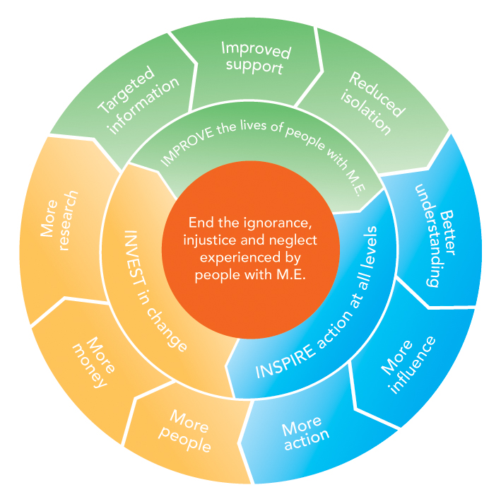
Around 50% of our activities will directly focus on targeting information, improving support and reducing isolation to IMPROVE the lives of children, young people and adults with M.E. To be as effective as possible, 30% of our activities will focus on facilitating more action, more influence and better understanding of M.E. to INSPIRE action at all levels; and 20% of our activities will be focused on bringing more research, more money and more people into the field to INVEST in change.

Role summary

Role title | Chair of Board of Trustees
Remuneration | This a voluntary role, with reasonable expenses paid.
Hours of work | Likely to equate to an average of three to four days per month; see p7 of application pack for further information.
Based in | Anywhere in the UK, with willingness to travel to London and Keynsham (between Bristol and Bath) for Board meetings.

Role purpose

Main duties:

- To provide effective leadership to the Board of Trustees/Directors ensuring that it fulfils its responsibilities and accountabilities for good governance of the Charity.
- To work in partnership with, and support, the Chief Executive helping them to achieve the mission of the organisation.
- To optimise the relationship between the Board and staff/volunteers.
- To create additional value for the Charity through soliciting additional resources in at least one of the following areas: policy/influence, awareness-raising, press/media and income generation.

In more detail:

To provide effective leadership to the Board of Trustees/Directors

- Ensure that the Board sets the vision, mission, top-level strategy and high-level policies for the Charity within the powers and restrictions in its charitable objects and governing documents.
- Ensure that Trustees fulfil their duties and responsibilities for the proper governance and legal compliance in all aspects of the Charity’s activities.
- Ensure internal controls and systems are in place (both financial and non-financial) and are audited and reviewed on a regular basis.
- Ensure that the Board regularly reviews its structure, role and relationship to
staff to create an effective flow of leadership and implements agreed changes as necessary to maintain effective performance and ensure it does not slip incrementally, or otherwise, into the management role.
- In close consultation with the Chief Executive, make recommendations on the composition of the Board, and future Chairs and officers of the Board (with a view to succession).
- With the Chief Executive, develop appropriate agendas for meetings ensuring that all matters requiring Board review are discussed and Chair meetings of the Board ensuring that it functions effectively.

To work in partnership with, and support, the Chief Executive helping them to achieve the mission of the organisation

- Ensure that the Board and the Charity puts people with M.E. at the heart of everything they do, listening to the voices and views of key stakeholders, especially people with M.E., the Chief Executive, staff and volunteers.
- Provide leadership to the Chief Executive to ensure the Charity is run in accordance with the decisions of the Board of Trustees and the Charity’s governing documents and that there is clarity about the Charity’s purpose and objectives at all levels.
- Ensure that through the Chief Executive, a performance evaluation process is in place for everyone in the Charity and that the Chief Executive is clear about the key performance indicators by which they will be held accountable.
- When necessary, ensure that the Chair and the Trustees challenge the Chief Executive constructively, as critical friends, and only in the best interests of the Charity.
- Ensure the Chief Executive understands their crucial responsibility to provide relevant, honest, timely, high-quality information and advice to the Board of Trustees.
- With the Chief Executive, ensure there are appropriate mechanisms, both internal and external, to verify that the Board of Trustees receives a balanced and honest picture of how the Charity is operating and performing.

To optimise the relationship between the Board and staff/volunteers

- Through the Chief Executive, ensure effective communication between the Board and the staff/volunteer team, and in particular, senior managers and ensure that the Chief Executive provides an effective link.
- Ensure through the Chief Executive that the staff understand the role of the Board of Trustees and that the Chief Executive provides an effective link between the Board, staff and volunteers.
- Ensure that whenever practicable, Trustees visit various parts of the Charity, attend appropriate events organised by the Charity and have informal opportunities to meet the staff, volunteers and beneficiaries.
- Comply with current employment and equalities legislation and good practice.

To create additional value for the Charity and solicit additional resources and support

- Use your expertise and own networks to create and secure support for the charity in at least one of the following areas: policy/influence, awareness-raising, press/media and income generation.
- Lead and encourage the Board in achieving similar and appropriate support for the Charity to maximise its reach and benefit for people with M.E.
- Represent and promote the Charity in a range of differing public and private forums, the press and media, as appropriate and agreed with the Chief Executive.

Person specification

The following are essential requirements:

- A commitment to the organisation, its purpose and cause.

- Demonstrate an understanding of M.E. and its impact on people with the illness and others affected by it.

- Proven leadership experience in an organisational setting ideally including experience as a Chair and/or Committee work.

- A willingness to devote the necessary time and effort. This will include a minimum of four Board meetings per year, an AGM, one-to-one sessions with the Chief Executive and ad hoc support and engagement outside of meetings. Together this is likely to equate to an average of three to four days per month.

- Ability to hold and set strategic vision.

- Good, independent judgment.

- Tact and diplomacy.

- Good communication and interpersonal skills.

- Impartiality, fairness and the ability to respect confidences.

- An understanding and acceptance of the legal duties, responsibilities and liabilities of trusteeship.

- An ability to work effectively as a member of a team.

- A willingness to participate in at least one sub-committee, as appropriate.

- A commitment to working within Action for M.E.’s values and principles of working, including Nolan’s ‘Seven Principles of Public Life’:

- Selflessness
- Integrity
- Objectivity
- Accountability
- Openness
- Honesty
- Leadership.

More information

All Trustees and Officers receive a full induction and there are bi-annual development days for Trustees with the CEO and Senior Leadership Team. We also provide a Trustee Handbook and a copy of NCVO’s ‘Good Trustee Guide’.

To ensure that the Board functions effectively, Trustees are expected to attend as many meetings as possible. We recognise that some people will not be able to travel due to M.E. therefore attendance and availability may be sporadic; where it aids accessibility teleconferencing will be possible although this may not be appropriate for some people.

Because of the critical role that Trustees play, where Trustees are not able to attend regularly and for a sustained period of time, a decision will need to be taken to take some ‘time out’ or to stand down. The Chair is required to attend most, if not all, Board meetings.

There are four sub-committees of the Board of Trustees, which you can read more about in our most recent annual report. It is anticipated that Trustees will participate in at least one sub-committee:
- Audit, Finance and Fundraising Committee
- Research Panel
- Policy Group
- Communications and Policy
- Remunerations and Nominations Committee (REMCO).

The Chair of the Board will also be required to Chair REMCO; this committee meets only when there is a need to.

How to apply

If you are interested in becoming our Chair, please submit your CV and completed Equal Opportunities Monitoring and Information Form below along with a covering letter outlining why you would like to become our Chair and how you meet all aspects of the person specification outlined above. You must also provide two referees who we can approach should you be successful following interview.

Please also indicate any reasonable adjustments that you may require to enable us to provide a good recruitment process with you.

Timetable

Closing date for applications | 9am Monday 10 June 2019
Interview and opportunity to meet some staff and Trustees | Wednesday 3 July 2019 at our Keynsham office
Candidates opportunity to observe Board meeting and meet other Trustees | Thursday 26 September 2019 in London
Supporting members voting (for new Trustees) | August to October 2019
AGM and confirmation of appointment | Tuesday 15 October 2019 in London

For more information, or to submit an application, please contact Anna Whitson at Action for M.E., 42 Temple Street, Keynsham BS31 1EH. Tel: 0117 927 9551.
Email: anna@actionforme.org.uk

Data Protection Act 2018
Information provided in any application will be treated as confidential and held in secure conditions. Access will be restricted to those involved in the recruitment and selection process. Data you provide may be copied for use in the recruitment process and once this is completed, the information will be stored for a maximum of 12 months and then destroyed. If you are the successful candidate, relevant information will be taken from your application and transferred to your personal file. We are unable to process your application unless we can use your personal data. By signing and submitting an application, you are giving your consent to the processing of your data in the ways described.

Pictured on the cover clockwise from top left: Great South 2017 runner Ben Brockway and his sister Laura; Action for M.E. supporter Sharon Blake,; Elizabeth Keyworth and friends having a fundraising tea party; Sonya Chowdhury, Chief Executive, with Profs Avindra Nath and Jose Montoya at CMRC research conference 2017; Fundraisers Sally Kendrick and her daughter Lauren; Mary-Jane Willows, Head of Children’s Services, with children and families at 10 Downing Street Christmas party 2017

Equal opportunities monitoring and information form

Action for M.E. is committed to its equal opportunities policy. This means that we shall treat all applicants and employees fairly and equally, irrespective of race, colour, age, ethnic or national origins, sex, religious belief, gender reassignment, trade union activity, marital status, sexual orientation or disability. The information you provide here is confidential, and will be used for monitoring purposes only. It will not be seen by the short-listing or interview panels. Please return this form with your application.

Please tick the boxes that apply to you:

Age group:  - 21 – 30  - 31 – 40  - 41 – 50  - 51 – 65  - 65+  - Do not wish to answer | Gender:  - Male  - Female  - Do not wish to answer
Ethnic Origin:  White  - British  - Irish  - Other European  - Other…………………………… | Asian  - Asian British  - Bangladeshi  - Indian  - Pakistani
Black  - African  - Black British  - Caribbean  - Other……………………………. | Chinese  - Chinese  Other  - Other……………………………

Equality Act 2010

The Equality Act protects people from unlawful legislation. If you tell us that you have disability, we will make reasonable adjustments to your working environment and your work practices, if it is reasonable for us to do so.

You’re disabled under the Equality Act 2010 if you have a physical or mental impairment that has a ‘substantial’ and ‘long-term’ negative effect on your ability to do normal daily activities.

Do you consider yourself to have disability? | - Yes*  - No

*If yes, please indicate which category best describes your disability:
- Hearing impairment
- Visual impairment
- Speech impairment
- Mobility impairment
- Physical co-ordination (eg. manual dexterity/muscle control)
- Reduced physical capacity (eg. severe pain, lack of strength, breath or stamina)
- Learning difficulties
- Mental illness
- Other……………………………………………………………………………...………………………………………………………………………………………………………..

Advertising and publicity
Please tell us how you heard of this vacancy:

- Website (please specify)………………………………………………………………….
- Newspaper (please specify)……………………………………………………………..
- Other (please specify)……………………………………………………………………..

Action for M.E.
42 Temple Street
Keynsham
BS31 1EH
Information and support: 0117 927 9551 (Monday to Friday 10am to 4pm)
Email: questions@actionforme.org.uk
www.actionforme.org.uk
@actionforme on Facebook and Twitter
@actionform.e on Instagram

