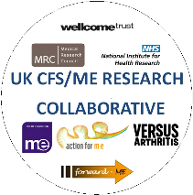
UK CFS/ME Research Collaborative (CMRC)
Membership Form

Please complete the form below and send it by email to research@actionforme.org.uk OR by post to UK CFS/ME Research
Collaborative, C/O Action for M.E., 42 Temple Street, Keynsham BS31 1EH.

Please make cheques payable to ‘CFS/ME Research Collaborative’ and
post with your application form to the address below.

For direct payment to the bank please mark as ‘Collaborative Membership’ and make the payment to account number 11415127,
sort code 16-13-18. Please email research@actionforme.org.uk to confirm
once payment has been made.

NAME

EMAIL

UNIVERSITY/
ORGANISATION/
NHS TRUST
ADDRESS

I confirm that I have read the CMRC overview and agree to work within the values of the CMRC. |  |  | YES / NO
I confirm that I am resident/working in the UK |  |  | YES / NO
Please tick relevant membership rate |  | Student: actively registered on a research, health or social care or related course with an academic intuition  Associate: anyone with an interest in CFS/ME research, including those with the illness, their carers and families  Professional: healthcare professional, researcher, charity or other organisation. | £15 per year  Free  £20 per year
Signed

Date

