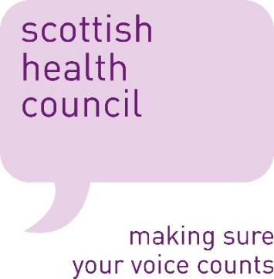

Information sheet for participants in face to face discussions.

Thank you for taking part in this discussion.

Please have a look over this information sheet which explains the purpose of the discussion and what your involvement would entail. If you have any questions, please ask the facilitator who is leading your local work.

What is the purpose of the survey?
This work is by the Scottish Health Council. We are part of Healthcare Improvement Scotland, which sits within NHS Scotland and helps health and social care services to improve. You can find out more about our work at www.scottishhealthcouncil.org

We are gathering views from people with Myalgic Encephalomyelitis (ME) on behalf of the Scottish Government to find out what good care would look like for them. The Scottish Government has determined a number of questions they’d like us to use with people who have ME.
They will use this information to inform recommendations on how Scotland should respond to findings of the Scottish Public Health Network needs assessment on ME, updated NICE guideline on ME and more widely to achieve the aims and commitments set out within the context of the five year Scottish Neurological Framework. Our report of the findings of this work may also be utilised, alongside other evidence, to inform developments for training purposes.

Why have I been asked to take part?
The Scottish Health Council is working with people who are living with a diagnosis of Myalgic Encephalomyelitis (ME) in Scotland to give their views about what support they would like to see in place.

Do I have to take part?
No. It is up to you to decide if you would like to take part. If you do not want to take part you do not have to explain why. However, your feedback would be a big help in helping to improve the services provided in the future.

Will any information I give be confidential?
Your responses will be treated confidentially. Discussion group transcripts will be stored on a secure PC. The findings from the interviews will be written up for a report and may be used in presentations. Your name will not be identified in the report or in any presentations.

What if I change my mind about taking part?
You are free to stop taking part at any time and you do not have to explain why.

What happens after I have taken part?
Once the interviews have been completed the results will be summarised in a final report. If you wish to receive a copy of the summary report it will be available on the Scottish Health Council website www.scottishhealthcouncil.org

For further information contact the local office
Scottish Health Council Fife
Flat 2
Willow Drive
Kirkcaldy
KY1 2LF
Tel: 01592 200555
Email: fife@scottishhealthcouncil.org

