Thank you for considering joining Action for M.E.
Action for M.E.
Services Team Leader
Application Pack

I joined Action for M.E. in September 2012 and am delighted to be working with a staff and volunteer team and Board of Trustees who are passionate, dedicated and determined.

Our 2016 – 2021 strategy, launched at our 2016 AGM and conference, sets out how we meet need now to improve the lives of people with M.E. while taking action to secure change for the future.

A small organisation that regularly punches above its weight, we are leading, with others, a growing community of supporters working to create real change on the scale so urgently needed at a local, national and international level.

In April 2017, we launched our Children’s Services after joining forces with national children’s charity, the Association of Young People with M.E. This provides an exciting opportunity to raise more money to reach more people and raise much needed awareness and understanding

I believe that Action for M.E. can, and will, make a major contribution to creating the change that is so desperately needed.

Sonya Chowdhury
Chief Executive

Our values

Shared values are held with high regard in our organisation and reflect how we seek to work with our supporters, partners and other key
stakeholders. They reflect the attitudes, beliefs and behaviour that we value in each other and underpin our whole approach and culture.

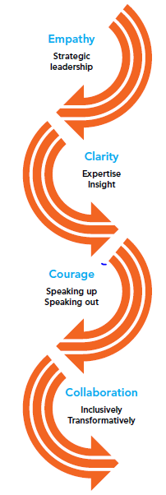

About us

Action for M.E. takes action to end the ignorance, injustice and neglect that people with M.E. face day-in, day-out.

The charity was founded by Sue Finlay in 1987 and since then has been working tirelessly to tackle the inequality experienced by people with M.E.

M.E. (Myalgic Encephalomyelitis) is a chronic, neurological illness affecting an estimated 250,000 adults and children in the UK. It may be diagnosed as Chronic Fatigue Syndrome (CFS, or M.E./CFS).

People with M.E. experience severe, persistent fatigue associated with post-exertional malaise, the body’s inability to recover after expending even small amounts of energy, leading to a flare-up in symptoms.

Even in its so-called mildest form, M.E. can have a significant impact on an individual’s life, and not just on their health. A lack of understanding and awareness about M.E. means patients can experience disbelief, and even discrimination, from friends, family, health and social care professionals, employers and teachers.

Our vision

A world without M.E.

Our mission

Empowering people with M.E. to fulfil their potential and secure the care and support they need, while working towards a greater understanding of the illness and ultimately a cure.

Our people

President
Clare Francis MBE

Vice President
Martin Arber

Patrons
Lord David Puttnam CBE
Lord Melvyn Bragg
Julie Christie
Alan Cook CBE

Honorary Patron
Ondine Upton

Chair of Board of Trustees
Roger Siddle

Vice Chair
Alison Deeth

Board of Trustees
We are an organisation led by people affected by M.E. for people affected by M.E. We aim to have a minimum of 51% of our Trustees who have, or have had, M.E. themselves.

Our Trustees are unpaid and meet at least four times a year and many sit on one of our four sub-committees. Board meeting location alternates between London and Keynsham.

We have a staff team of 24 (19.6 FTE), one sessional staff member and approximately 70 volunteers who support our work in a number of different ways.

Our head office is in Keynsham (between Bath and Bristol) and we also have a small number of staff and volunteers in Scotland, plus a staff member in the Midlands.

Over the next five years, our purpose is to end the ignorance, injustice and neglect experienced by people with M.E.

Children, young people and adults with M.E. are at the heart of everything we do. We asked and we listened, and have identified a number of challenges that continue to exist for people affected by M.E.

Everything we do over the next five years will be in service of achieving three goals, which we call our strategic touchstones.

By collaborating with those who share our vision and purpose, we make the most of the resources available to us.
Around 50% of our activities will directly focus on targeting information, improving support and reducing isolation to IMPROVE the lives of children, young people and adults with M.E.

To be as effective as possible, 30% of our activities will focus on facilitating more action, more influence and better understanding of M.E. to INSPIRE action at all levels; and 20% of our activities will be focused on bringing more research, more money and more people into the field to INVEST in change.

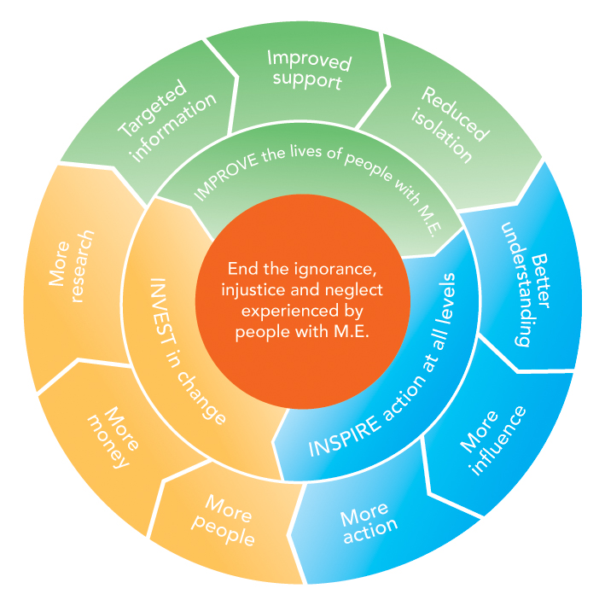

Job summary

Job title | Services Team Leader
Responsible to | Operations Director/Deputy Chief Executive
Responsible for | Children’s Services Team; Info, Support & Welfare Team; Advocacy Coordinator; volunteers
Salary | £32-35k per annum dependent on experience
Hours of work | 35 hours per week
Annual leave | 30 days per annum plus bank holidays
Location | Keynsham office

Job purpose

The purpose of this post is to provide operational management to the Action for M.E. services teams. This post will play a crucial part in helping the charity to end the ignorance, injustice and neglect experienced by people with M.E. through generating income to fund its work.

Key duties

1 Service management

- Lead the day-to-day operations of the Children & Young People and Info, Support & Welfare services, ensuring high quality service provision that meets all best practice, legal and regulatory frameworks and internal policies and procedures
- Develop and deliver annual work plans across the three services teams (Regional Advocacy, Children & Young People and Info, Support and Welfare)
- Provide effective line management and leadership to the Family Support Worker, Peer Support Officer, Info & Support Senior Practitioner and Advocacy Coordinator for the delivery and development of services to empower and support children and families affected by M.E.
- Contribute to the learning and development of the staff team including coaching and mentoring support to enhance performance.
- Working closely with the Operations Director, develop and implement strategy and delivery plans for Action for M.E. services, responding to identified need and proactively leading on improvements to the service.
- Embed continuous quality improvement within the services, using data to continually develop and improve the work of the team.
- Ensure that all statutory requirements relating to safeguarding, HR, health and safety and data protection are met.
- To work creatively as a member of the Management Team to ensure that the needs of people with M.E., including children and families, are at the heart of our work and that delivery is integrated across all services.
- Ensure reporting on the effectiveness and impact of service delivery with robust output and outcome measures in place, including monthly management information reporting.
- To work proactively with the fundraising and communications teams to identify potential funders and to maximise income to enable the charity to reach more people and meet more need.
- Working closely with the Operations Director, proactively manage risk within the services, and respond appropriately to any issues as they arise.
- Provide day to day financial oversight of the CYP and Info & Support departmental budgets

- External engagement
- To represent Action for M.E. at external events and conferences, as required
- To nurture relationships with key stakeholders working with children, young people, adults, Carers and families affected by M.E.

- Other duties

- Ensure effective recording of all work with children, adults and families in accordance with best practice and the Charity’s policies and procedures.
- Support colleagues in delivering services to all beneficiaries
- Positively promote the work and activities of Action for M.E. at all times.
- Keep up-to-date with best practice and comply with relevant legislation and regulatory requirements, working within the organisation’s policies and procedures and ensure that good practice is observed.
- Undertake any other reasonable activity in line with the responsibilities of the post as requested by the Operations Director

Person specification

Education
- A wide base of further education and training to degree level or equivalent in areas relevant to the job description OR demonstrable professional experience commensurate to that required for this role.

Experience and Knowledge
- Demonstrable professional experience of project and/or service delivery, preferably in the VCSE sector
- An understanding of M.E., the impact on people affected by it or a commitment and ability to understand the illness and lead services to meet the needs of children and adults with M.E.
- Experience of delivering results, project management and leading management information reporting.
- Experience of leading teams at management level
- Experience of managing budgets
- Proven experience of building and nurturing strong relationships internally and externally at all levels.
- A sound understanding of outcome-focused, effective performance management
- An understanding of income generation in the voluntary sector.

Skills and Behaviours
- Strong interpersonal skills including motivational and networking to build strong internal and external relationships.
- An ability to understand, analyse and make effective use of data across all of our work.
- A proven ability to coach and motivate staff and to build and lead teams reflecting organisational culture and values, a respectful, constructive and energetic style.
- Ability to multi-task, prioritise and effectively manage a varied workload with competing priorities in a flexible and tenacious manner.
- Strong MS Office skills that supports writing, email, internet and database use.
- Ability to work flexibly including some evenings and weekends

Attitudes
- Perseverance
- Integrity
- Openness
- Compassionate
- Collaborative

Terms and conditions

Outlined below are some of the main terms and conditions of employment relevant to all employees of Action for M.E.

1. Probation
All posts are subject to three months’ probation. During this probationary period, either party may give the other one week’s notice in writing to terminate the employment. After successful completion of the probationary period, the notice stated on your contract of employment will apply.

2. Annual leave
The holiday year runs from 1 April to 31 March. In each holiday year in addition to bank and statutory holidays the holiday entitlement for a full time employee is 30 days (includes 3-4 days to be taken at Christmas as directed when the office is shut).

3. Pension scheme
Action for M.E. operates a group pension scheme on an auto-enrolment basis. All employees will join the scheme on the completion of the probationary period unless they choose to opt-out. Action for M.E. will pay a pension contribution which is currently 4% of salary. Action for M.E. will not pay into a personal pension scheme

4. Salary payment
Salaries are paid in arrears on the last working day of each month, by direct credit transfer into a bank or building society.

5. Flexibility
This post may require working outside of normal office hours and travel to attend meetings and events within the UK, including occasional overnight stays.

Application timetable

Deadline for applications | 9am Monday 16 March 2020
Short list meeting | 17 March 2020
Interviews (to be held in Keynsham) | 31 March 2020

For more information, or to submit an application, please contact Elyssa Marshall at Action for M.E., 42 Temple Street, Keynsham BS31 1EH. Tel: 0117 937 6632.
Email: elyssa@actionforme.org.uk

Application form
for the post of
Services Team Leader

Please PRINT and use black ink if not completing electronically. This form must be completed in full. Any additional information submitted (eg. CV) will not be considered in the shortlisting process.

Personal details

Surname | First name(s) | Title
Address

Email address

Office hours telephone number | Other hours telephone number | Mobile number
Do you need a work permit for permanent employment in the UK? YES / NO |  | If so, do you have one?  YES / NO

Please provide education history and qualifications

Name of school, college or university | Date  from – to – | Qualifications gained
Please provide full work history (please ensure you account for any gaps in employment. Only provide a very brief summary of responsibilities as this will not be taken into account in scoring your application).

Job title and responsibilities | Organisation/Employer | Date  from – to – | Reason for leaving

Please provide current salary details (or last post if not in current employment) £_______

Please describe, in no more than two pages, why you want this role and how you fit all aspects of the person specification set out in this pack.
Why you want this role, cont’d.
Referees

Name  Address  Telephone  E-mail address:  Relationship to you | Name  Address  Telephone  E-mail address:  Relationship to you

Declaration

I declare that all the information I have given on this application form is true to the best of my knowledge and belief. I understand that my application may be rejected and/or that I may be dismissed if I have given information which is found to be false.

Consent to contact references

I consent to Action for M.E. contacting my named referees in accordance with its normal policy if I am the successful candidate following the selection process.

Signed…………………………………………………………..

Date……………………………………………………………...

Please return this form to elyssa@actionforme.org.uk

Data Protection Act 2018
Information provided on this application form will be treated as confidential and held in secure conditions. Access will be restricted to those involved in the recruitment and selection process. Data you provide may be copied for use in the recruitment process and once this is completed, the information will be stored for a maximum of 12 months and then destroyed. If you are the successful candidate, relevant information will be taken from your application and transferred to your personal file. We are unable to process your application unless we can use your personal data. By signing and submitting this form, you are giving your consent to the processing of your data in the ways described.

Pictured on the cover, clockwise from top left: Great South 2017 runner Ben Brockway and his sister Laura; Action for M.E. supporter Sharon Blake,; Elizabeth Keyworth and friends having a fundraising tea party; Sonya Chowdhury, Chief Executive, with Profs Avindra Nath and Jose Montoya at CMRC research conference 2017; Fundraisers Sally Kendrick and her daughter Lauren; Mary-Jane Willows, Head of Children’s Services, with children and families at 10 Downing Street Christmas party 2017
Equal opportunities monitoring and information form

Action for M.E. is committed to its equal opportunities policy. This means that we shall treat all applicants and employees fairly and equally, irrespective of race, colour, age, ethnic or national origins, sex, religious belief, gender reassignment, trade union activity, marital status, sexual orientation or disability. The information you provide here is confidential, and will be used for monitoring purposes only. It will not be seen by the short-listing or interview panels. Please return this form with your application.

Please tick the boxes that apply to you:

Age group:  - 21 – 30  - 31 – 40  - 41 – 50  - 51 – 65  - 65+  - Do not wish to answer | Gender:  - Male  - Female  - Do not wish to answer
Ethnic Origin:  White  - British  - Irish  - Other European  - Other…………………………… | Asian  - Asian British  - Bangladeshi  - Indian  - Pakistani
Black  - African  - Black British  - Caribbean  - Other…………………………….. | Chinese  - Chinese  Other  - Other……………………………
Mixed race  - White and Asian  - White and Black African  - White and Black Caribbean | - White and Chinese  - Other……………………………..

Equality Act 2010

The Equality Act protects people from unlawful legislation. If you tell us that you have disability, we will make reasonable adjustments to your working environment and your work practices, if it is reasonable for us to do so.

You’re disabled under the Equality Act 2010 if you have a physical or mental impairment that has a ‘substantial’ and ‘long-term’ negative effect on your ability to do normal daily activities.

Do you consider yourself to have disability? | - Yes*  - No

*If yes, please indicate which category best describes your disability:
- Hearing impairment
- Visual impairment
- Speech impairment
- Mobility impairment
- Physical co-ordination (eg. manual dexterity/muscle control)
- Reduced physical capacity (eg. severe pain, lack of strength, breath or stamina)
- Learning difficulties
- Mental illness
- Other……………………………………………………………………………...……………………………………………………………………………………………….

Advertising and publicity
Please tell us how you heard of this vacancy:

- Website (please specify)………………………………………………………
- Newspaper (please specify)……………………………………………………….
- Other (please specify)………………………………………………………

For more information
Visit our Online M.E. Centre at www.actionforme.org.uk where you can find out more about M.E. and the work we do or contact Action for M.E. on 0117 927 9551

