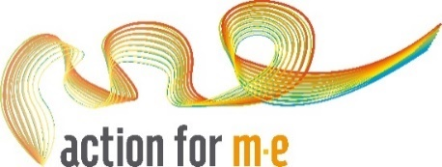

Action for M.E. Great North Run 2022 application
First name:
Last name:
Email address:
Phone number:
Address:
Why do you want to run for Action for M.E.?
Have you fundraised for Action for M.E. before? If yes, please give details of the event/activity.
Does your employer run a match giving scheme? If so please state how much they will raise up to.

How did you hear about Action for M.E. Great North Run places?
We'd love to stay in touch! Please let us know your contact preferences below (please tick relevant boxes)
Action for M.E. can contact me by email about their work, research, fundraising and services.
Action for M.E. can contact me by post about their work, research, fundraising and services.
Action for M.E. can contact me by phone about their work, research, fundraising and services.
Please only contact me about the Great North Run 2022 and my related fundraising

By submitting this application form for an Action for M.E. Great North Run place, you commit to paying a £35 registration fee, and raising a minimum sponsorship of £350 if you are selected for the team. If you have any questions, please contact our fundraising team on 0117 927 9551 or email us at fundraising@actionforme.org.uk
Thank you!

