

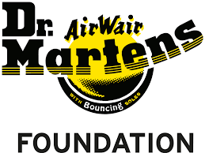
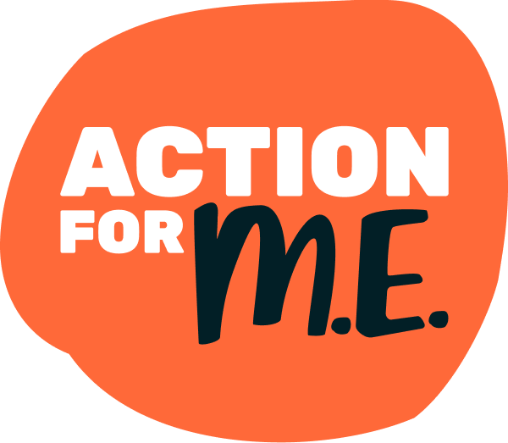

Young People’s Counselling service referral form

Section A: details of the young person who wants to access counselling (this section must be completed)
First name: | Surname:
Address including postcode: | Telephone number (mobile preferred):
Date of birth:

Age at application:
Email address:
My diagnosis (please tick):  I have a diagnosis of ME  I have a diagnosis of CFS  I don’t have a formal diagnosis but have ME-type symptoms | My ME symptoms are:  mild  moderate  severe  very severe
I am seeking support with (please give a BRIEF summary):

My GP’s name and address (we explain in section B why we ask for this):

How did you hear about our Young People’s Counselling service?

Action for ME’s website

Facebook

Instagram/Threads

TikTok

Bluesky

Other (please specify):
Are you part of Action for ME’s Young People’s Community? (please tick)

Yes No

If no, would you like further information on our Young People’s Community? It’s free to join and offers a range of free services where you can connect with others, like our friendly online forum (please tick).

Yes No
The best way to communicate with me is (please tick):

Phone Email
PLEASE NOTE we may sometimes send a text to your mobile phone to highlight the offer of an appointment which has been sent by email.
Best time/s of day to contact me:
Section B: data protection and consent
Please read this section, then sign and date it below
You can find further information about how we process and use your data by reading our Privacy Policy, available online at http://www.actionforme.org.uk/privacy-policy/ or we can send you a copy by post.

We will use your email/telephone number to keep in contact with you and send you information that you have request or consented to us sending.

If we believe that you are at serious risk of harm, abuse or neglect and this falls within CYP legislation, we may use your personal details to refer you to the Children’s Services in your local area.

Wherever possible we will seek your consent to do this, however if we believe that this will put you or another person at an increased risk of harm then we may contact the Children’s Services team or call the emergency services without your consent.

Information is only shared within Action for ME on a need-to-know basis. We may need to liaise with your GP and other healthcare agencies.

Declaration of consent
- I give permission for Action for ME to process my personal data in order to provide a service to me.
- I understand that no action will take place without my knowledge and consent and all information will be treated as confidential unless there is evidence or reasonable cause to believe I or another person is at risk of harm, abuse or neglect or if a crime has taken place/will occur.
- I understand that only necessary information about the work you are doing with me will be recorded and it will be stored electronically in a safe way.
- I understand that if I agree to my personal data being shared, I have the right to limit how much is shared or to withdraw my agreement at any time.
- I understand that I can decide that I do not want my information to be shared anymore. I understand that this will affect the way Action for ME can help me.
Declaration of third-party consent (if applicable):
- I give permission for the person/s named in section C to communicate with the Healthcare Services team on my behalf.
Signature: | Date:
Section C: please only complete this section if you are submitting this form on behalf of a young person who wants to access counselling.
Your name:

Your relationship to the young person (e.g. parent(s), guardian, carer, professional):

Organisation (if applicable):

Your email:

Your telephone number:

Has the young person consented to this referral?

Yes No

Data protection
- You can find further information about how we process and use your data by reading our Privacy Policy, available online at http://www.actionforme.org.uk/privacy-policy/ or we can send you a copy by post.
- We will use your email/telephone number to keep in contact with you.

Declaration of consent
- I give permission for Action for ME to process my personal data in order to provide a service.

Your signature:

Date:

